天主教道明中學第101學年度第二學期第三次月考二年級英語科試題
康軒版B4 Lesson7-Review3
- 文意字彙：20%(需完全答對才給分)
- How s d I am. I lost my wallet again
- My mom bought a lot of new clothes in the famous d t s e, Harrods.
- The London Eye is the tallest F s w l in the UK.
- It’s s e and easy to make cookies, and they are yummy.
- A ns speak louder than words. Just do it.
- The full moon s e in the sky last night.
- Everyone should know the importance of a - g and fight against school bullies.
- Don’t tell your name or phone number to a s r.
- Write your boss back as soon as p e because it’s a rush job.
- They put an a t not only in the newspaper but on TV, and the cost was expensive.
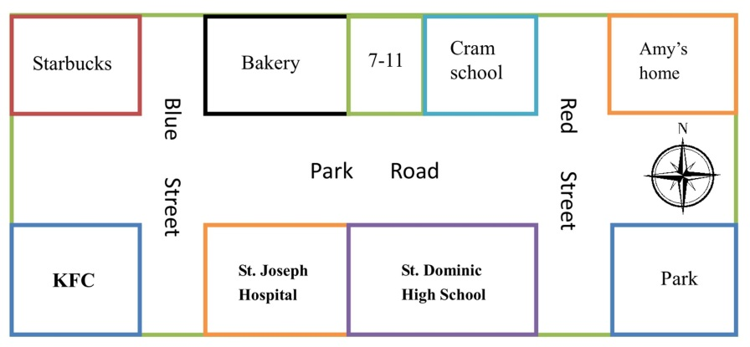
- 克漏字填充：10%
I’m Amy. I’m going to move to Tainan, so my house is 1. sale. Every morning, I liked to walk 2.a Park Road 3. two blocks and drank a cup of coffee in Starbucks. Sometimes, I bought some bread in the bakery, and it’s 4. 5. St. Joseph Hospital. Like many students, I often bought my breakfast in 7-11. The convenience store is 6. the bakery and the cram school. In the afternoon, I loved to go
7.d Red Street from my home to the park. I often thought of those good old days when I studied in St. Dominic High School next 8. St. Joseph Hospital. The hospital is 9. the left of my school. On holidays, my friends and I met 10. front of KFC and ate our lunch.

- 文意填充(3-9題根據提示字，依照句意填入最適當的詞性與級)：10%
- The key success is in your hand if you always do your best.
- The sign in the shop says, “It’s time to change your house a castle.”
- Lucy speaks good French. She speaks French (good).
- Mary felt so (sad) that she didn’t go to the concert with her friends.
- You should exercise (much) to stay healthy.
- Tony came to school (early) than Tom.
- Of all the animals, turtles run (slow).
- Jack plays basketball (terrible) than all the other boys.
- The1. (many/much), the2. (good). (愈多愈好)

- 文法選擇：30%
- ______ letters are these? They are _____.
(A) Whose; our (B) Who’s; my (C) What; us (D) Whose; his
- The dresses here are too small. Let’s go see _____ over there.
(A) one (B) the ones (C) them (D) it
- It looks like _______ outside. Take an umbrella with you.
(A) rains (B) rain (C) raining (D) rainy
- He walked ______ this morning.
(A) half a miles (B) one and a half mile
(C) a half mile (D) a half miles
- The students _______ last weekend.
(A) went whale watching (B) went watching whale
(C) went whales watching (D) went to watching whales
- The weather is getting ________.
(A) hot and hot (B) even hot
(C) hottest (D hotter and hotter
- Petty is ______ of the two girls.
(A) the taller (B) taller than (C) very tall (D) much taller
- The horse is _____ of all the animals.
(A) the faster (B) the fastest (C) the most fast (D) pretty fast
- David looks _______ Tom.
(A) as heavier as (B) so heavier as
(C) as heavy as (D) so heavy as
- Did you see Nina _____ in the park?
(A) practicing to dance (B) to practice dancing
(C) practice dance (D) practice dancing
- Helen and I made the cake _____.
(A) themselves (B) ourselves (C) herself (D) myself
- The doctor had Father _______.
(A) to try not to smoke (B) try not smoking
(C) try not to smoke (D) trying to not smoke
- New York is _____ than any city in Taiwan. In fact, it is _____ city in the world.
(A) big; the most big (B) much bigger; biggest
(C) the biggest; the bigger (D) bigger; the biggest
- I fell off (落下) the bike and broke my leg. It really _____ now.
(A) get hurt (B) hurts a lot
(C) is hurt (D) hurt very much

- Billy went to the train station _______.
(A) by bus (B) by take a bus
(C) on bus (D) in a bus
- _____ pets makes us ______.
(A) Keeping ; to feel happy (B) Keeping; feel happy
(C) Keep; feeling happy (D) To keep; to feel happy
- You may ask the questions ____ Mr. Lin.
(A) to (B) for (C) of (D) with
- Alice likes the watch a lot. Why not ______?
(A) buy her it (B) buying her it
(C) to buy it to her (D) buy it for her
- A: Wow! The computer game is ＄500. But _____.
B: Really? So I just have to pay ＄350.
(A) it’s 30% off today (B) it’s 70% off today
(C) it’s free (D) it’s too expensive
- Judy has ______ dolls in her house. She really loves dolls.
(A) two hundreds (B) three hundred
(C) hundreds of the (D) two hundreds and fifty
- ______ rich the man is!
(A) How (B) What (C) Who (D) Why
- He swims as ______as his brother ______.
(A) good; is (B) quickly; can
(C) well; does (D) fast; may
- You ______ out at night.
(A) don’t had better go (B) had not better go
(C) had better not go (D) had better not to go
- ______ so noisy. The baby is sleeping.
(A) Stop to be (B) Stop being
(C) Stopping to be (D) To stop being
- If you _____ right now, you _____ a discount.
(A) will pay; will have (B) pay; have
(C) pay; will have (D) will pay; have
- Mr. White looked ______ at the boy.
(A) pretty happy (B) happier (C) happy (D) happily
- Which is correct?
(A) Please call him back as soon as you can.
(B) He is possible to win the race.
(C) The bike took him $1000.
(D) The price of the iPhone is so expensive.
- It _____ me some time _____ the computer this morning.
(A) spent; fixing (B) cost; to fix
(C) took; fixing (D) took; to fix
- He spent all afternoon _______ yesterday.
(A) playing piano (B) playing basketball
(C) to play basketball (D) play the piano
- Excuse me. ______ can I get to the post office?
(A)How (B) Where (C) Which (D) What
- 閱讀測驗：30%
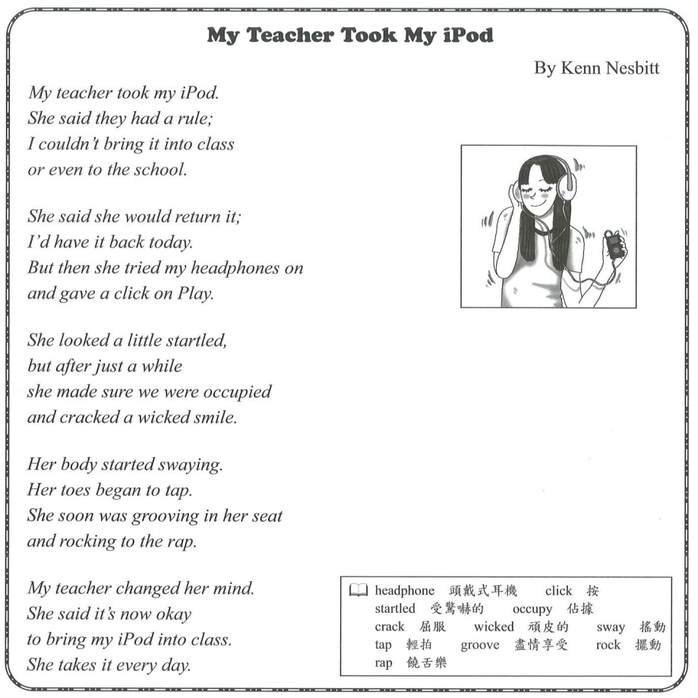
【A】

- What can we know from the poem?
(A) Kenn’s teacher likes music.
(B) Kenn brings her iPhone to school.
(C) All the students sing along with the iPod.
(D) Both Kenn and her teacher have their own iPod.
- Why did the teacher change her mind?
(A) She found Kenn’s iPod brings joy.
(B) She put her headphones on.
(C) She gave a click on.
(D) She returned Kenn’s iPod.

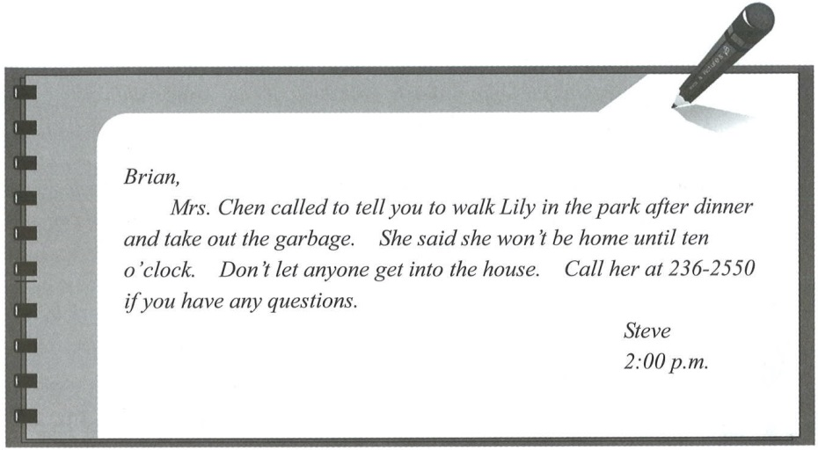
【B】

- What can we learn from the note?
(A) Brian and Steve are brothers.
(B) Lily is Steve’s sister.
(C) Brian’s mom will get home late tonight.
(D) Brian’s dad is with his mother.
- What is not mentioned in the note?
(A) Call Mrs. Chen at 236-2550.
(B) Feed Lily before walking her.
(C) Walk Lily in the park.
(D) Take out the garbage.
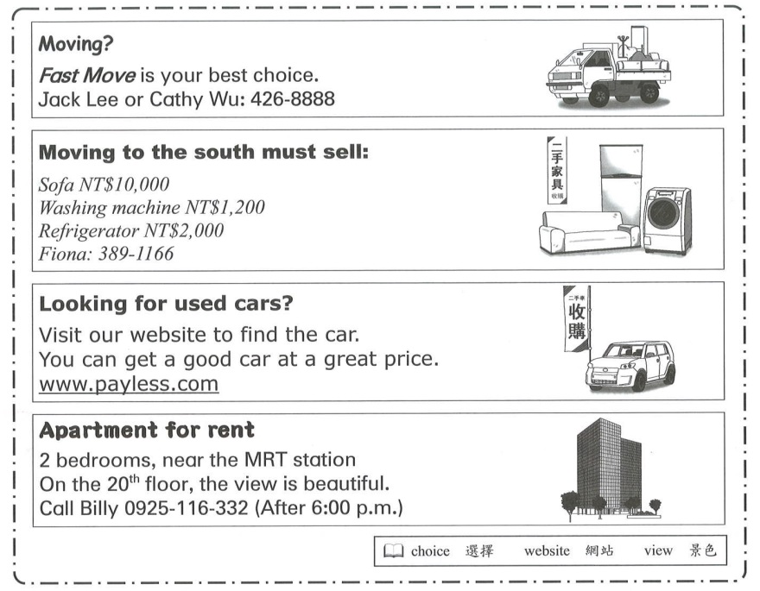
【C】
- Which is true?
(A) Fiona is looking for an apartment in the south.
(B) The used car is cheap, but less useful.
(C) Billy helps people move fast.
(D) The view on the 20th floor is beautiful.

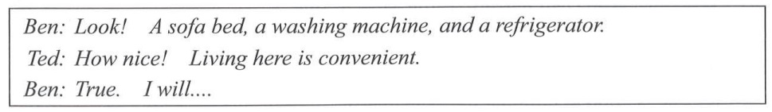

What will Ben do?
(A) Call 389-1166.
(B) Get on the website.
(C) Phone Billy after 6:00p.m.
(D) E-mail Jack Lee.
【D】
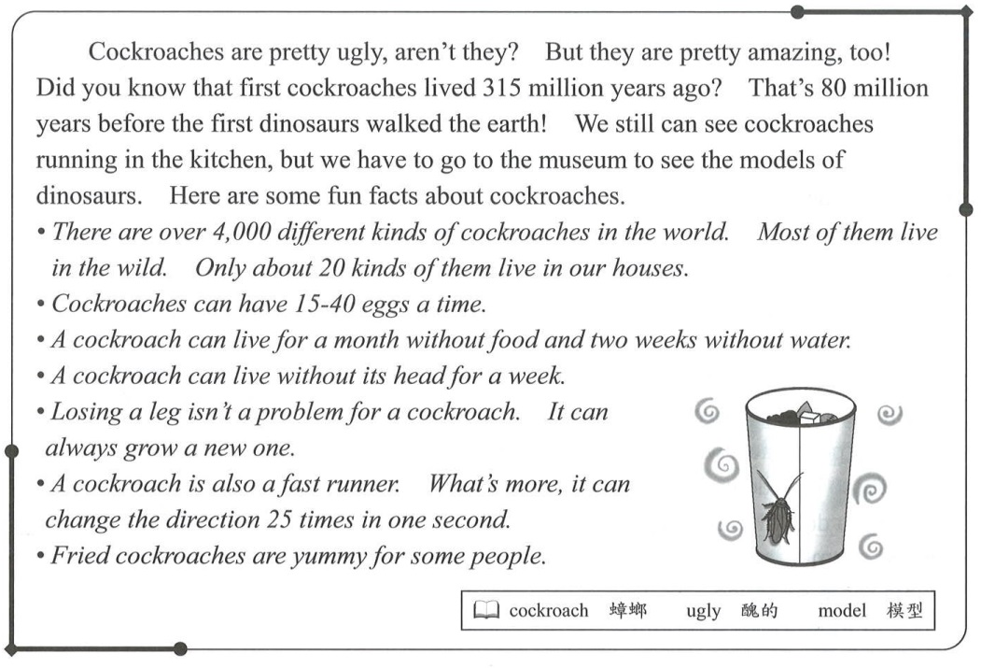
- How many kinds of cockroaches live with people?
(A) 315. (B) 80. (C) 4000. (D) 20.
- Which is true about cockroaches?
(A) They can have 100 babies at a time.
(B) They are fast runners, but they can’t change directions.
(C) Dinosaurs are later on earth than cockroaches.
(D) They can live without heads.

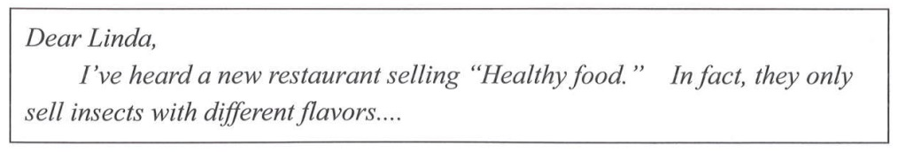
flavor 味道
What may be on the menu?
(A) Fried rice.
(B) Fried cockroaches.
(C) Fried chicken.
(D) French fries.

【E】
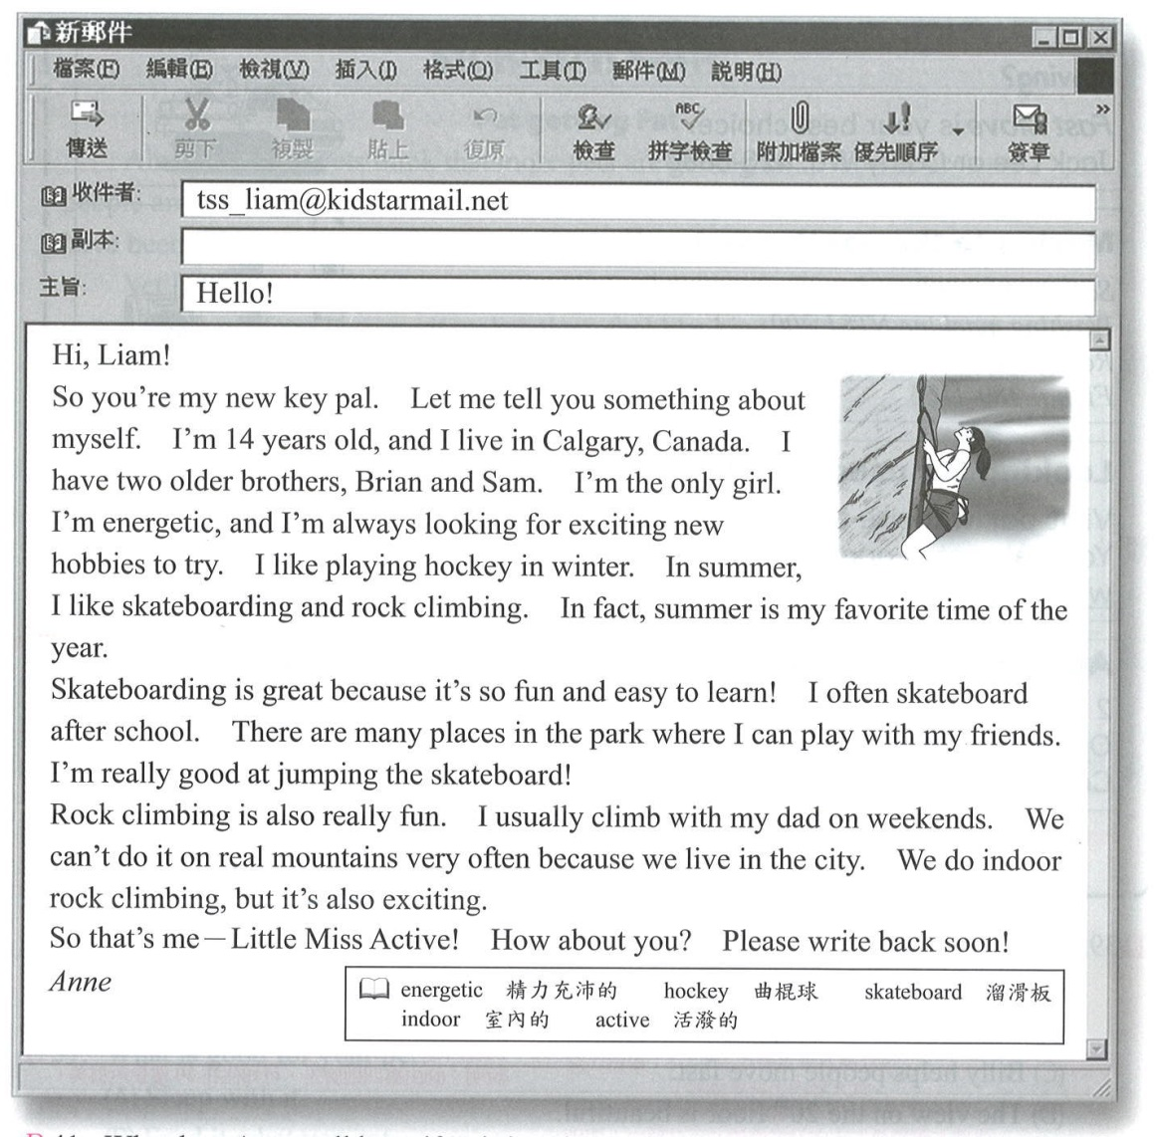
- Why does Anne call herself “Little Miss Active”?
(A) She’s good at jumping the skateboard.
(B) She likes exciting activities.
(C) She likes summer.
(D) She’s the only girl at home.
- Which is true?
(A) Brian and Sam are father and son.
(B) Liam and Anne have known each other.
(C) Anne likes indoor rock climbing as well.
(D) Anne and her father go mountain climbing on weekends.
- What do we know about Anne?
(A) She’s the youngest child in her family.
(B) She’s a student living in the city.
(C) She’s good at some exciting activities.
(D) All of the above.

【F】
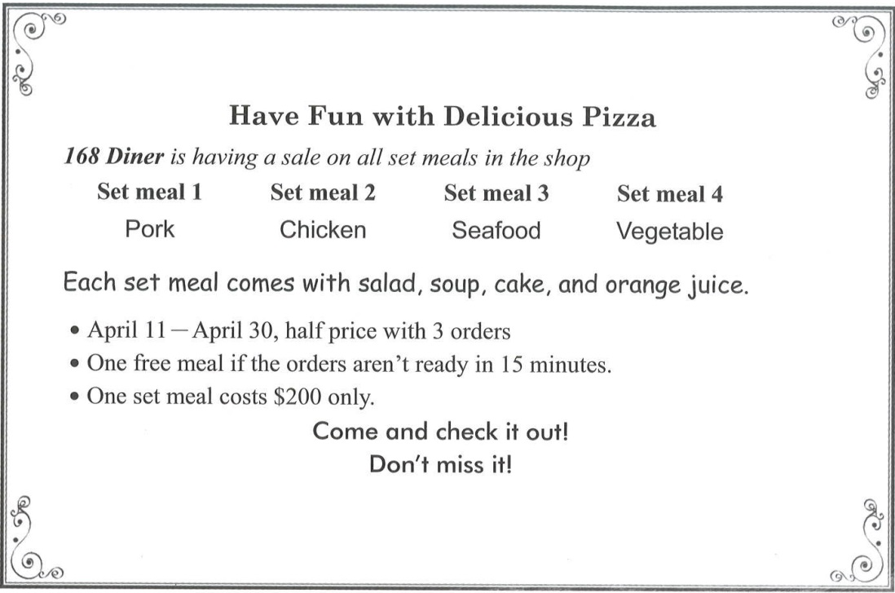
- What CAN’T you have at 168Diner?
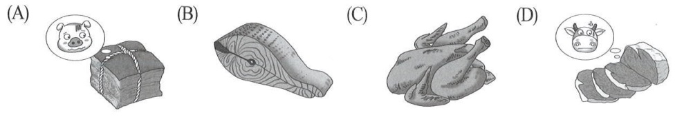
- What kind of food does 168 Diner serve?
(A) Pizza. (B) Steak. (C) Burger. (D) Beef noodles.
- Nancy and her two friends went to 168 Diner on April 24. All the orders were 16 minutes late. How much did they pay for the meal?
(A) $0. (B) $200. (C) $300. (D) $800.

天主教道明中學第101學年度第二學期第三次月考二年級英語答案卷
二年______班 座號______ 姓名_________________

- 文意字彙：20% | 二、 克漏字填充：10% | 三、 文意填充：10%
1. stupid | 1. for | 1. to
2. department store | 2. along | 2. into
3. Ferris wheel | 3. for | 3. well
4. simple | 4. across | 4. sad
5. Actions | 5. from | 5. more
6. shone | 6. between | 6. earlier
7. anti-bullying | 7. down | 7. (the) most slowly
8. stranger | 8. to | 8. more terribly
9. possible | 9. on | 9. (1)more
10. advertisement | 10. in | (2)better

四、文法：30 % (答案欄請劃斜線)
 | 1. |  | 2. | 3. |  | 4. |  | 5. | 6. | 7. |  | 8. | 9. | 10 | 11 | 12 | 13 | 14 | 15
A |  |  |  |  |  |  |  | ◎ |  | ◎ |  |  |  |  |  |  |  |  | ◎
B |  |  | ◎ | ◎ |  |  |  |  |  |  |  | ◎ |  |  | ◎ |  |  | ◎
C |  |  |  |  |  | ◎ |  |  |  |  |  |  | ◎ |  |  | ◎
D | ◎ |  |  |  |  |  |  |  | ◎ |  |  |  |  | ◎ |  |  | ◎
 | 16 | 17 |  | 18 | 19 |  | 20 |  | 21 | 22 | 23 |  | 24 | 25 | 26 | 27 | 28 | 29 | 30
A |  |  |  |  | ◎ |  |  |  | ◎ |  |  |  |  |  |  | ◎ |  |  | ◎
B | ◎ |  |  |  |  |  | ◎ |  |  |  |  |  | ◎ |  |  |  |  | ◎
C |  | ◎ |  |  |  |  |  |  |  | ◎ | ◎ |  |  | ◎
D |  |  |  | ◎ |  |  |  |  |  |  |  |  |  |  | ◎ |  | ◎

五、閱讀測驗：30 % (答案欄請劃斜線)
 | 1. | 2. | 3. | 4. | 5. | 6. | 7. | 8. | 9. | 10 | 11 | 12 | 13 | 14 | 15
A | ◎ | ◎ |  |  |  |  |  |  |  |  |  |  |  | ◎
B |  |  |  | ◎ |  |  |  |  | ◎ | ◎ |  |  |  |  | ◎
C |  |  | ◎ |  |  | ◎ |  | ◎ |  |  | ◎
D |  |  |  |  | ◎ |  | ◎ |  |  |  |  | ◎ | ◎

