天主教道明高級中學102學年度第一學期第二次段考國三英語科試題
康軒版Book5 Lesson5~ Lesson7
一、文意字彙：10%
- Ada h ed up and down happily in the classroom when she heard the good news.
- Jeremy Lin is the i l of many people that like basketball.
- Students can learn many new skills from those v l lessons.
- The story of Nick Vujicic i ed many people in the world. It’s very powerful.
- It was a p e to meet the VIP, Mark Zukerberg, at the party then.
- People believe the s ts will come back to the world on All Hallows Day.
- We will g e from junior high school next year and become senior high school students.
- The poor old man has n g but a little money and food. He needs our help.
- The d r, Karl Lagerfeld, has been a leader in the company, CHANEL, for many years.
- Kids are always happy to get red e es with money in them.

二、課文文意介系詞填充：10%
- Take Qing-Yang Xiao _____ example, now he’s world-famous.
- When you stand at home base and swing your bat, you have to focus your mind _____ the ball.
- Emily thinks the classes and skills will make John sail successfully _____ his future.
- When Nick Vujicic was little, he was often laughed _____ by his classmates.
- Nick Vujicic is a man _____ arms and legs.
- Steve thought Nick Vujicic and Lady Gaga had something _____ common.
- After Joe read Nick Vujicic’s story, he is filled _____ hope.
- In the USA, many people think a rabbit’s foot is a symbol _____ good luck.
- Tony tried last week and got full marks _____ all his tests.
- Frank thinks that was because _____ Tony’s hard work, not his wish list.

三、填入正確的字詞形式：10%
- Thank you for _____ (be) so nice to me for a long time.
- Why does Ben keep ______ (tell) the same story? He’s very boring.
- Many people know that ______ (teach) is learning.
- All of us should work hard ______ (make) a difference in our life.
- The practice will help the player ______ (hit) a home run.
- Jessie and Amy saw David ______ (sit) on the bench yesterday.
- The basketball game was ______ (excite) to many students at school.
- English and Chinese ______ (speak) in many places now.
- Brenda and Whitney ______ (know) each other for 60 years. They are old friends
- Children are ______ (bore) with soap operas.

四、選出最合適的答案：14%
  - Uncle Sam just ______ that he _____ us to MOMA in New York tomorrow morning.
(A) said; take (B) says; will take (C) said; would take (D) says; takes
  - We’ re not sure if it ______ tonight. You’d better take an umbrella with you.
(A) will rain (B) rains (C) rained (D) isn’t raining
  - Whether it ______ or not, we’ll go to the baseball game tomorrow.
(A) will rain (B) rains (C) rained (D) isn’t raining
  - If you ______ to your parents before making choices, you may not be successful.
(A) won’t listen (B) didn’t listen (C) don’t listen (D) aren’t listening
  - Mark ______ a nurse, but now he’s a singer.
(A) got used to be (B) has been used (C) is used to be (D) used to be
  - I don’t know ______.
(A) what are you happening (B) how it could happen
(C) what you happened (D) how happened to you
  - Is there ______ for dinner today? I hate to eat the same food every day.
(A) anything special (B) any special things
(C) special something (D) special some things
  - Nancy bought ______ tangerines for her family.
(A) two dozens (B) half dozen (C) half dozen of (D) dozens of
  - Does anybody know the girl ______ green dress and ______ a red handbag?
(A) wears; takes (B) in; with (C) with; in (D) of; without
  - George told Mary ______ she must do before she went to the movies with her friends.
(A) whether (B) that (C) if (D) what
  - The tea is ______ hot for the boy ______.
(A) too; to drink (B) so; that can’t drink
(C) too; to drink it (D) so; that can’t drink it
  - Everyone in my family is good at languages ______ me. I’m poor at English.
(A) beside (B) besides (C) except (D) without
  - The question is ______ difficult ______.
(A) too; for he to answer (B) so; that I can’t answer it
(C) too; to be answered (D) so; not to answer for me
  - Karen is wondering ______.
(A) who can she invite to the party (B) why Peter come here
(C) what to do next (D) how to do next

五、克漏字與閱讀測驗：50%
〔A〕Read the following passage and fill in the blanks with the correct answers.
My grandma passed away last May. She was a woman who loved her family, especially me. She always 1 a hand to other people, and everyone around her respected her very much.
Two years ago, Grandma had a stroke(中風) and had to stay in the hospital. Dad and Mom became very busy running between the house and the hospital. Ten months later, Grandma died. I couldn’t believe I 2 her again.
Today is Grandma’s 82nd birthday. She 3 us for a whole year already. I really want to tell her how much I miss her.

- (A) lends (B) lent (C) has lent (D) is lending
- (A) didn’t see (B) will not see (C) am not seeing (D) wouldn’t see
- (A) left (B) leaves (C) has left (D) is leaving

〔B〕Read the following passage and fill in the blanks with the correct answers.
Psyche was the beautiful daughter of a king and queen. She looked like a goddess. No man thought he was 4 to marry her.
One day, Psyche’s parents asked an oracle(神諭) 5 about their daughter. The oracle said Psyche should first 6 a wedding dress. Then she should be taken to a mountain and be given to a terrible monster(怪獸)!
When Psyche 7 on the mountain, something very strange happened. A warm breeze(微風) carried her to a beautiful castle(城堡). There, she was treated very well.
At night, Psyche was visited 8 a secret lover. She only heard his voice and felt his warm touch. She could not see her new husband, but still she was happy. He even let Psyche 9 her two sisters, but told her to be careful.
The sisters saw that Psyche was very happy, and they didn’t like it. So they fooled Psyche into seeing 10 her husband was. That night, Psyche held a light next to her husband while he was sleeping. She found out he was Cupid, the god of love!

- (A) well enough (B) enough well
(C) good enough (D) enough good
- (A) what to do it (B) how to do it
(C) what to do (D) how to do
- (A) take off (B) take away
(C) put off (D) put on
- (A) was left (B) has left
(C) left (D) has been left
- (A) for (B) by (C) to (D) with
- (A) to visit (B) visit (C) visited (D) visiting
- (A) who (B) what (C) where (D) how

〔C〕
Audrey is very busy this month. She has many appointments(約會) and meetings, and she even has to go out of town. Look at Audrey’s schedule and answer the following questions.

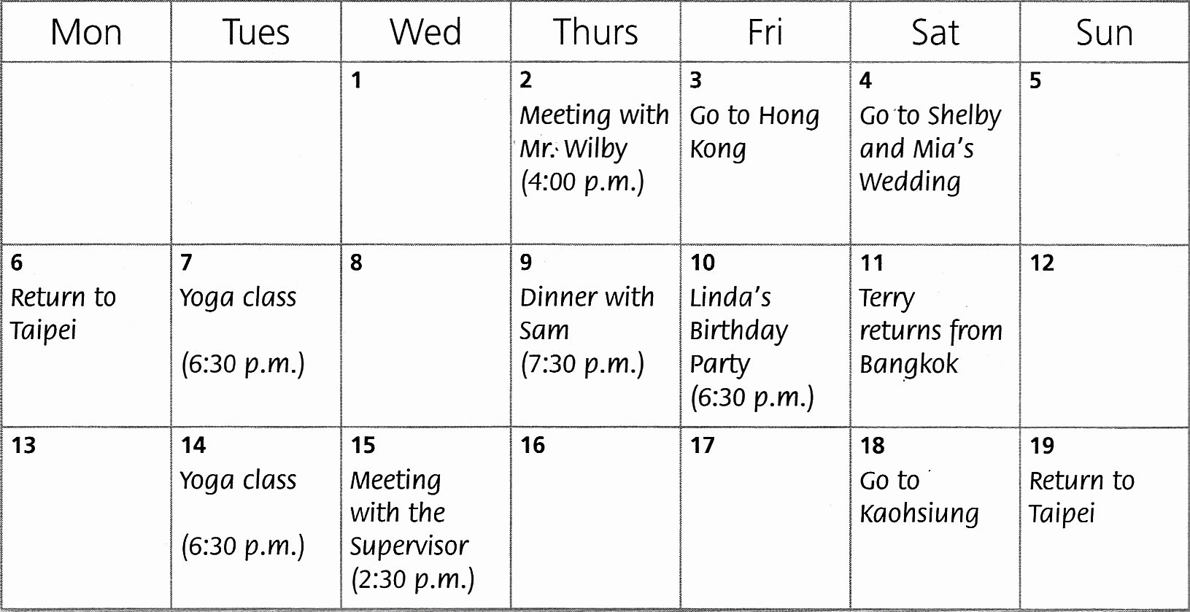
supervisor 主管
- Audrey has to go to a wedding this month. Where will the wedding be?
(A) Taipei. (B) Bangkok. (C) Hong Kong. (D) Kaohsiung.
- How many nights will Audrey spend in Kaohsiung?
(A) 1 (B) 2 (C) 3 (D) 4
- When does Terry return from Bangkok?
(A) Two days after Linda’s birthday party.
(B) The day before Audrey’s yoga class.
(C) On the first Saturday of the month.
(D) A week before Audrey goes to Kaohsiung.

〔D〕
Alice: My husband’s friends are coming from Holland to Taiwan on business this week. I want to
show them around on the weekend. But I don’t know where to take them.
John: How about Sun Moon Lake? They would love it there.
Alice: Thanks. But I really took them there last time.
John: How about Yangmingshan? The hot springs there are famous. After Yangmingshan, you can
take them to Shilin Night Market. The snacks there are delicious. I love the meatballs.
Alice: I don’t think so.
John: Why not? No one can say “No” to delicious food.
Alice: I’m afraid they are vegetarians. They aren’t big fans of meat.
John: That’s too bad. I don’t mean vegetarians are bad but they will miss out on a lot of fun.
Alice: I understand. Thanks anyway.

- What is true about Alice’s guests?
(A) They come from a country of America.
(B) This isn’t their first time visiting Taiwan.
(C) They want to travel around Taiwan on their own.
(D) They visit Taiwan for its beautiful scenery.
- Why does John say “No one can say “No” to delicious food?”?
(A) He doesn’t like the answer “No.”
(B) He can’t cook, but he likes good food.
(C) He thinks Alice’s friends will love good food.
(D) He doesn’t eat much because he’s on a diet.
- What does “vegetarians” mean?
(A) People who eat only vegetables.
(B) People who never eat vegetables.
(C) People who love eating meat.
(D) People who grow vegetables.

〔E〕Cell Phone Novels
In the 19th century, newspapers often published(出版) novels in parts. Chapters were printed one at a time. Telling the whole story took several weeks or months. At the start of 21st century, the cell phone novel was born. It married an old idea with new technology(科技).
There are several ways to read a cell phone novel. Readers may go to special websites(網頁) to read a chapter or download(下載) it to their phone. Or, chapters may be sent to a person’s phone via e-mail or short message. Chapters are short---often no more than a few hundred words long.
The first cell phone novel, Deep Love, was written by Yoshi, a Japanese writer. It was very popular, and it was later published as a book and made into a movie. The first Chinese cell phone novel was Distance. It was written in 2004 by Taiwanese writer Xuan Huang. The story contained(包含) 1008 roles and was divided into 15 chapters.

- When did cell phone novels become popular?
  - In the late eighteenth century.
  - In the nineteenth century.
  - In the middle of the twentieth century.
  - In the early twenty-first century.
- How can you read novels on your cell phone?
(A) Surf the Net and go to some special websites.
(B) Download them from some websites.
(C) Receive emails or short messages.
(D) All of the above.
- What do cell phone novels and novels in newspapers share between them?
(A) They are both products of modern technology.
(B) They are both told in parts.
(C) They are both, on average(平均), a few hundred words long.
(D) They are both printed on paper.

- Who is Xuan Huang?
(A) The world’s first cell phone novelist.
(B) A reporter for Chinese newspaper.
(C) A person who has written 15 novels.
(D) The writer of the novel Distance.
- What is referred to(提到) cell phone novels?
(A) Horror stories are read by many fans.
(B) Less than 1000 words are on the market.
(C) Most of them are written in English.
(D) Expensive phones are needed to read them.

〔F〕A Life Without Limits
Nick Vujicic is a speaker and a writer from Australia. He was born in December 4th, 1982. When he was seventeen, he started a nonprofit organization(非營利組織), Life Without Limbs(肢體). At twenty-one, he got two degrees from college. Nick sounds like an ordinary person, but he is truly amazing. He learned to play soccer, play golf, go surfing, go swimming, and so on. In 2010, he published Life Without Limits. This book discussed rising above his physical disabilities(肢體障礙). He says, “Find your life’s purpose and never give up, no matter what difficulties stand in your way.” He always looks at the bright side, and married Kanae last year in Los Angeles and had their son this year. Nick continues to travel around the world and cheer up people with his incredible(不可思議的) story.

- How old did Nick Vujicic get married?
(A) Twenty-nine.
(B) Thirty.
(C) Thirty-one.
(D) Thirty-two.
- What did Nick Vujicic create Life Without Limbs for?
(A) To make a fortune.
(B) To publish the book, Life Without Limits.
(C) To give a hand to others.
(D) To make his name.

〔G〕King Grisly-Beard
This is a story of a beautiful but very impolite princess.
One day, the king invited several princes to the castle. Those princes all proposed(求婚) to the princess, but she just made fun of them. She saw a prince with a beard and said, “His beard(鬍子) is ugly. It looks like a mop.” Finally, she called the prince “King Grisly-Beard.” What she did made the king the prince very angry, and they came up with an idea to teach the princess a lesson.
The next day, a flute player came to the castle. He played a song and then asked for some coins. The king said, “You win my daughter and take her home now.” No matter how the princess begged the king, he didn’t change his mind.
The princess married the flute player and lived a poor life, so she had to make money by working in the market. Although she worked hard, she earned a little and was always hungry. Later, the princess got a new job. Every morning, she walked for a long time to mop floors and wash clothes in a castle. When she worked there, she was very sad and felt very homesick.
One day, the princess bumped into(巧遇) King Grisly-Beard in the castle. His beard was gone, and he looked very handsome. He said, “I’m the flute player, your husband. I’ve pretended(假裝) to be another person for half a year. Your father and I wanted to teach you something. You can’t judge people by their appearance(外表).”
They both move back into the castle in the end. The kings were happy that the princess learned her lesson. After that, the princess was always nice to others.

- What was wrong with the princess before she got married?
(A) She was talkative.
(B) She was rude.
(C) She was selfish.
(D) She was critical.
- What did the king father and King Grisly-Beard decide to do?
(A) To take the princess to a class.
(B) To teach the princess to be a great housewife.
(C) To bring the princess to school.
(D) To make the princess a better person.

六、翻譯：6%
- 信不信由你，我上禮拜試過。
- 我不確定是否該修實作課程。
- 我希望能跟你一樣，成為一個擁有寬大心胸的人。

天主教道明高級中學102學年度第一學期第二次段考國三英語科答案卷
三年______班 座號______ 姓名_________________

一、文意字彙：10% | 二、課文文意介系詞填充：10% | 三、填入正確字詞形式：10%
1. hopped | 1. for | 1. being
2. idol | 2. on | 2. telling
3. vocational | 3. into | 3. teaching
4. inspired/ intersted | 4. at | 4. to make
5. pleasure | 5. without | 5. (to) hit
6. spirits | 6. in | 6. sit/ sitting
7. graduate | 7. with | 7. exciting
8. nothing | 8. of | 8. are spoken
9. designer | 9. on | 9. have known
10. envelopes | 10. of | 10. bored

四、文法：14% (答案欄請劃滿斜線或塗滿格)
 | 1. | 2. | 3. | 4. | 5. | 6. | 7. | 8. | 9. | 10 | 11 | 12 | 13 | 14
A |  | ◎ |  |  |  |  | ◎ |  |  |  | ◎
B |  |  | ◎ |  |  | ◎ |  |  | ◎ |  |  |  | ◎
C | ◎ |  |  | ◎ |  |  |  |  |  |  |  | ◎ |  | ◎
D |  |  |  |  | ◎ |  |  | ◎ |  | ◎

五、克漏字與閱讀測驗：50% (答案欄請劃滿斜線或塗滿格)
 | 1. | 2. | 3. | 4. | 5. | 6. | 7. | 8. | 9. | 10 | 11 | 12 | 13 | 14 | 15 | 16 | 17 | 18 | 19 | 20 | 21 | 22 | 23 | 24 | 25
A |  |  |  |  |  |  | ◎ |  |  | ◎ |  | ◎ |  |  |  | ◎
B | ◎ |  |  |  |  |  |  | ◎ | ◎ |  |  |  |  | ◎ |  |  |  |  | ◎ |  | ◎ | ◎ |  | ◎
C |  |  | ◎ | ◎ | ◎ |  |  |  |  |  | ◎ |  |  |  | ◎ |  |  |  |  |  |  |  | ◎
D |  | ◎ |  |  |  | ◎ |  |  |  |  |  |  | ◎ |  |  |  | ◎ | ◎ |  | ◎ |  |  |  |  | ◎

六、翻譯：6% (每題2分)
- Believe it or not, I tried that/it last week.
- I’m not sure if/ whether I should take hands-on classes (or not).
- I hope I can/ to be(come) a person with a big heart like you.

