天主教道明高級中學第102學年度第二學期第一次段考國一英文科試題
一. 文意字彙 10%
1. We always do many experiment (實驗) in s________e class.
2. T________s are the symbols (象徵) of long life
3. Mr. Li always gives us a lot of e________es to help learn better.
4. Jack is packing(打包) the books with a r_______e.
5. There is a basketball c_________t in the gym.
6. The e______rs have problems fixing the computers. They need help.
7. A big typhoon (颱風) is coming. The weather (天氣) is very t_______e.
8. Math is d______t for some students. They can’t learn it well.
9. This week in school we are studying the h______y of our town.
10. Ms. Chen and Ms. Huang are b_______n. They sell (賣) shoes.

二. 動詞形式 (每格不限一字) 20%
1. John _______ (watch) TV on Sundays, but I don’t.
2. David _______ (hurry) to school every morning.
3. Who ________ (sit) in the classroom now?
4. What animals _______ he _______ (not like)?
5. Look! Sue’s friend, Helen, _____ (ride) a bike in the park.
6. They _________ (read) and writing in the English class.
7. Mr. White ______ (have) a new girl friend now.
8. They _______ ( do ) their homework, but my brother does.
9. Cathy ,______ (go) to the door and close it.
10. Tom _____ (not be) late to work every day.

三.文法選擇 20%
- Andrew has _____ dodge ball. He likes to play _____ dodge ball.
(A) a ; a (B) a ; X (C) X ; X (D) X ; a
- Leo: _____ Sam’s sisters go to school late every day ?
Alex: No, only today.
(A) Do (B) Are (C) Does (D) Is
- The class _____. Look! They are very happy.
(A) have a lunch (B) is having lunch (C) are having lunch (D) eats lunch
- Tim: Can I _____ a great baseball player in the future (未來)?
Sam: Of course, if you practice (練習) hard
(A) am (B) is (C)are (D) be
- Tom: My cousin doesn’t go swimming every day. Joe: Wow! Me ,_______.
(A) too (B) also (C) either (D) neither
- Please help me _____ my housework. (選出錯誤的)
(A)do (B) to do (C) with (D) for
- Tony never gets good grades _____ Chinese. He needs to study hard.
(A) on (B) in (C) at (D) with
- Kent: Mom, I can’t fix the computer.
Mom: I can’t, either. Let’s ask your dad _____ help. (A) to (B) with (C) for (D) of
- A: Don’t you have any brothers? B: Yes, I do.
(A) I have brothers (B) I have no brothers (C) I don’t have any brothers. (D) I have brothers but no sisters.
- We have _____ English class this morning
(A) no (B) not a (C) no an (D) not
- Helen has _____ every night.
(A) much homeworks (B) many homeworks (C) a lot of homeworks (D) lots of homework
- Wash your hands, _____ you can have the cake.
(A) then (B) and (C) but (D) or
- _____ you and your sister _____ home?
(A) Do ; X (B) Does ; at (C) Are ; X (D) Do ; at
- A: Everyone _____ the basketball game. B: Yes. It’s exciting.
(A) like (B) is liking (C) likes (D) are liking
- We have fifteen teachers in our class. One is a man, and ______ are women.
(A) other teachers (B)the other (C) the other teachers (D) others
- Emily: Girls’ Generation is coming! I can’t wait to see them. Let’s _____ the show. Lily: That’s great. I love them, too. Girls’ Generation (少女時代)
(A) to join (B) joining (C) join (D) joins
- A: That is a great movie. B: ______
(A) You bet. (B) They do. (C) No wonder. (D) How’s it going?
- The boy _____ two big bags _____ my brother.
(A) has ; are (B) has ; is (C) with ; are (D) with ; is
- A: This is an e-bike card, not a telephone card. B: ______ it different?
(A) How’s (B) What’s (C) Where’s (D) Who’s
20. A: Ted can’t go to the park with us. B: _______
(A) That’s right. (B) That’s too bad
(C) What is he doing? (D) What can he do?

四.克漏字選擇 18 %
Kevin: Do you like to listen to music?
Tony: Yes. I like all kinds of music. And I can play the guitar.
Kevin: I like pop music, ___1.___ I can’t play any instrument.
Tony: I see. And do you like _2._____?
Kevin: Of course I do. I’m on the school basketball team. I can play basketball__3._____.
Tony: Really? Then, are you free this afternoon? How about __4.___ basketball together?
Kevin: No problem.
Instrument 樂器
1. (A) but (B) and (C) so (D) or
2. (A) pets (B)sports (C)computers (D) fries
3. (A) very good (B) many (C) very much (D) very well
4. (A) play (B) playing (C) plays (D) to play

Carol: Mom, can I go to Amy’s birthday party tonight?
Mom: ___5.____ She is your best friend. So is Amy a Sagittarius?
Carol: __6._____
Mom: No wonder. You two get along
Carol: Yeah. She likes animals,___7.____.
Mom: What do you always do after school?
Carol: We play tennis together. She __8.._____ tennis, so she teaches me. She is a good coach.
Mom: ___9.____!
Best 最好的 Sagittarius 射手座 get along 相處融洽
5. (A) How’s it going? (B) How come? (C) No, you can’t. (D) Yes, you can.
6. (A) I don’t get it. (B) No, it isn’t. (C) You bet. (D) She isn’t.
7. (A) too (B) also (C) either (D) else
8. (A) is good in (B) is well at (C) does good play (D) is good at
9. (A) What nice she is! (B)What a nice girl! (C) How a nice girl! (D) How nice is the girl!

五.閱讀測驗 22%
Lisa is my pet. She is an artist. She likes painting. She jumps around with colors on her feet and paints pictures. Many people like her art works.
Lisa likes music, too. She jumps around to music and that’s really cute. It’s a Small World is her favorite song. By the way, rabbits don’t like water, but Lisa does. She is a good swimmer. She’s really special. Isn’t she?
Painting(繪畫) feet(腳)
1. Does Lisa have her favorite song?
(A) No, she doesn’t. (B) No, she doesn’t like music. (C) Yes, she can dance to music. (D) Yes, she does. It’s It’s a Small World.
2. What CAN’T Lisa do?
(A) Sing songs . (B) Swim well. (C) Jump around. (D) Draw pictures.

George and Mary are a black dog and a white cat. George likes to go out for a walk. Every evening he goes to the park with his owner, David. David rides his bike and George runs after him. Sometimes they play ball or frisbee. George does a lot of exercise, but he doesn’t like to take a bath. David gives him a bath every Saturday afternoon. Mary doesn’t like to do any exercise. She walks slowly and is always lazy. She likes to lie on the sofa and take a nap. She always keeps herself clean, but she never takes a bath. George and Mary are really different.
Owner主人 exercise運動 bath洗澡 lie躺 nap小睡 moon月
3. What does George NOT like to do?
(A)Go for a walk. (B) Take a bath (C) Play frisbee. (D) Go running.
4. How many times a month does George take a bath?
(A) One (B) Two (C) Three (D) Four
5. Which is true?
(A) Mary likes to take a bath.
(B) George likes to go for a walk with Mary.
(C) George is a white dog.
(D) George and Mary are pets.

Moving?
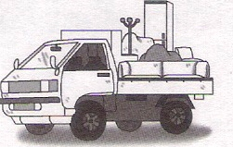
Fast Move is your best choice.
Jack Lee or Cathy Wu: 426-8888

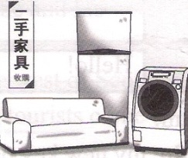
Moving to the south must sell:
Sofa NT$10,000
Washing machine NT$1,200
Refrigerator NT$2,000
Fiona: 389-1166
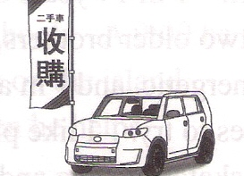
Looking for used cars?
Visit our website to find the car.
You can get a good car at a great price.
www.payless.com
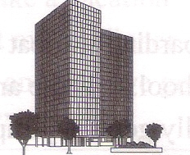
Apartment for rent
2 bedrooms, near the MRT station
On the 20th floor, the view is beautiful.
Call Billy 0925-116332 (After 6: 00 p.m.)
choice 選擇 washing machine 洗衣機 refrigerator 冰箱website 網站
price. 價格 apartment公寓 rent 出租 view 景色
6. Which(哪一個) is right?
(A) Fiona is looking for an apartment in the south.
(B) The used car(二手車) is cheap, but less(較少)useful.
(C) The view on the 20th floor is beautiful.
(D) Billy helps people move fast.
7.
Ben: Look! A sofa bed, a washing machine, and a refrigerator
Ted: How nice! Living here is convenient(方便).
Ben: True. I will….
What will Ben do?
(A) Call 389-1166 (B) Get on the website
(C) Phone Billy after 6: 00 p.m. (D) E-mail Jack Lee.

Seamus is a very busy man. He is 60 years old, and he has 10 jobs. He a mailman, a police officer, a fire fighter, a taxi driver, a school bus driver, a boatman(船夫), an ambulance(救護車)driver, a restaurant waiter , and he also works in a gas station(加油站)and in a bookstore, Also, he and his wife, Margaret, have a shop and a small hotel.
Seamus lives and works on the island of Gigha in the west of Scotland(蘇格蘭). Only 120 people live on the island but in the summer 150 tourists(觀光客) come by boat every day.
Every weekday Seamus gets up at 6:00 and makes breakfast for the hotel guests. At 8:00 he drives the island’s children to school. A 9:00 he gets the mail from the boat and delivers(投遞) it to all the houses on the island. He also delivers wine to the island’s only restaurant, Then he helps Margaret in the shop.
He says “Margaret likes being busy, too. We never take a vacation(假期) and we don’t like watching TV. In the evenings, Margaret makes dinner and I feed my pet dogs. At 10:00 we have a glass of milk and then we go to bed. Perhaps(或許)our life isn’t very exciting, but we like it.”

8. Which is true about Seamus?
(A) He can drive the taxi, the bus, and the rain.
(B) He has 10 jobs, so he has to get up before 5:00.
(C) He likes his busy life, and his wife does, too.
(D) He and his wife also run a bookstore.
9. How many people visit Gigha a week in summer?
(A) 120 (B) 150 (C) 840 (D) 1,050

Here is some advice(建議)on learning English. First, read English stories to learn more words. If you do not know what a word in the story means, try to guess(猜)it by looking at the sentence. If that does not work, you can then look it up in a dictionary(字典). Second, watch more English TV shows and movies. This will help you better understand the culture(文化) and see how English is used in daily life(日常生活). If you are watching a DVD, try turning off the Chinese subtitles(字幕) so that you can make yourself listen to English. Third, try talking to foreigners when you have the chance(機會), as it will help you become more confident(自信的). Lastly, have fun. There is no way to be good at English if you do not enjoy the language(語言). If you keep the advice in mind(在心中), your English will get better and better.
10. What does the writer think about subtitles in DVDs?
(A)We should(應該) try not to use Chinese subtitles.
(B) We should try our best to follow the subtitles.
(C) Chinese subtitles are useful for us in learning English.
(D) We should use English subtitles.
11. Which advice is NOT given(給) by the writer?
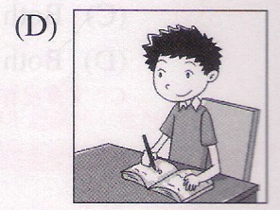
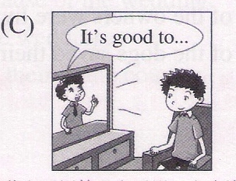
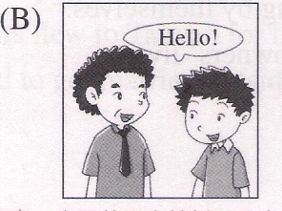
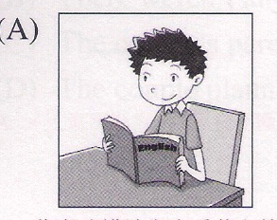

六.依提示作答及翻譯: 10%
1. Grandma is sleeping, so keep your voice down. (改寫為印刷體)
2. Is your friend from America? ( 用 come 改寫)
3. Rick同時用三枝筆寫字。
4. Bunny在這兩學科上都得到好成績。
5.加入羽球社吧！我們有優秀的教練。

一、文意字彙10%(每題1分) 二、動詞形式20%(每題2分)
1.science | 6.engineers | 1.watches | 6.are reading
2.Turtles | 7.terrible | 2.hurries | 7.has
3.examples | 8.difficult | 3.is sitting | 8.don’t do
4.rope | 9.history | 4.doesn’t like | 9.go
5.court | 10.businesswomen | 5.is riding | 10.isn’t

三、文法選擇20%(每題1分)
 | 1 | 2 | 3 | 4 | 5 | 6 | 7 | 8 | 9 | 10 | 11 | 12 | 13 | 14 | 15 | 16 | 17 | 18 | 19 | 20
A |  | V |  |  |  |  |  |  | V | V |  |  |  |  |  |  | V |  | V
B | V |  |  |  |  |  | V |  |  |  |  | V |  |  |  |  |  |  |  | V
C |  |  | V |  | V |  |  | V |  |  |  |  | V | V | V | V
D |  |  |  | V |  | V |  |  |  |  | V |  |  |  |  |  |  | V

四、克漏字選擇18%(每題2分) 五、閱讀測驗22%(每題2分)
 | 1 | 2 | 3 | 4 | 5 | 6 | 7 | 8 | 9 | 1 | 2 | 3 | 4 | 5 | 6 | 7 | 8 | 9 | 10 | 11
A | V |  |  |  |  |  | V |  |  |  | V |  |  |  |  | V |  |  | V
B |  | V |  | V |  |  |  |  | V |  |  | V
C |  |  |  |  |  | V |  |  |  |  |  |  |  |  | V | V | V
D |  |  | V |  | V |  |  | V |  | V |  |  | V | V |  |  |  | V |  | V

六、依提示作答及翻譯: 10%
1.Grandma is sleeping, so keep your voice down.

2.Does your friend come from America?

3.Rick writes(words) with three pens at the same time.

4.Bunny gets good grades in these two subjects.

5. Join the badminton club! We have excellent coaches.

