天主教道明高級中學103學年度第二學期第二次段考國中一年級英語科試卷
(範圍：康軒版B2 L4~Review2)
- 選出最適合的答案：32%
  - Tom: do you go to the movies? Gary: Every other day.
(A) What time (B) What (C) How about (D) How often
  - Ella: do the students play baseball? Betty: Sunday mornings.
(A) What day; Every (B) What days; In
(C) What day; On (D) What days; At
  - Calera: Katherine: Ten o’clock. (Choose the WRONG answer)
(A) Do you have time? (B) What time is it?
(C) Do you have the time? (D) What time is it by your watch?
  - It’s 12 a.m.
(A) It’s time to bed. (B) It’s time to eat lunch.
(C) It’s time for bed. (D) It’s time for school.
  - Let’s some hot soup. I’m a little cold now.
(A) eating (B) eat (C) drink (D) to drink
  - Frances do housework after work, but I do.
(A) has to (B) hasn’t to (C) doesn’t has to (D) doesn’t have to
  - Who your sisters study science with?
(A) do (B) does (C) is (D) are
  - Harry plays every day. (Choose the WRONG answer)
(A) the chess (B) badminton (C) the piano (D) with the dog
  - Darren: Who watering the flowers in the garden? Silvia: George and Mary .
(A) can; can (B) does; do (C) are; are (D) is; are
  - Ian: Don’t you always do online shopping? Ken: No,
(A) I don’t always. (B) I always do.
(C) I seldom do. (D) I never.
  - Do you have brother or sister?
(A) any (B) some (C) many (D) much
  - Ms. Brown says, ” go to school late”
(A) Too often (B) Never (C) Always (D) Sometimes
  - May I ask a question you?
(A) to (B) for (C) with (D) of
  - Philips: Henry: It’s Friday. (Choose the WRONG answer)
(A) What day is your birthday? (B) What day is it?
(C) What day is today? (D) What day is it today?
  - Kevin’s new car .
(A) isn’t enough good for him (B) is good enough for him
(C) is very good enough for him (D) isn’t good enough of him
  - Can you help me my homework? (Choose the WRONG answer)
(A) to do (B) do (C) doing (D) with

- 克漏字選擇：12%
【A】
Ms. Wang often brings her class several decks(副) of word cards. She believes that by 17 , students would find it more fun to review English words and remember the words better at the same time. The game is played like this below.
The students get into groups of 4 or 5. For each group, a deck of cards is put on the desk, the sides with words facing down. 18 , the students turn a card over by turns.(輪流) The student that first 19 and its Chinese meaning gets the card. At the end of the game, the student that gets the most cards wins.
17. (A) watching interesting English movies (B) playing the word game
(C) writing each word several times (D) taking lots of tests
18. (A) First (B) And then (C) For example (D) However
19. (A) puts the card back (B) finds the card
(C) shouts the name of the student (D) says the word on the card

【B】
(Ben is in a shoe store. Jane, a clerk of the store, is talking to him.)
Jane: May I help you?
Ben: I’d like to buy a pair of shoes.
Jane: 20
Ben: No, they are for my wife.
Jane: I see. 21
Ben: I’m not sure. But I know it’s much smaller than mine.
Jane: We can’t get the shoes for you if you don’t know her size.
Ben: Is it possible to buy a pair of your size first and get another pair later if it doesn’t fit(適合)?
Jane: If you say so. But what kind of shoes would you like?
Ben: I can only buy shoes that are not expensive. 22
Jane: You can pay with your credit card.(信用卡)
Ben: I don’t have a credit card, either.
20. (A) Do you like these shoes? (B) Are the shoes comfortable?
(C) Are the shoes for yourself? (D) Is it your birthday?
21. (A) What’s her size? (B) What does she want?
(C) Does she like smaller shoes? (D) Is red her favorite color?
22. (A) I don’t have much free time. (B) I hate to spend too much money.
(C) I don’t have much money. (D) I need to hurry home.

- 閱讀測驗：36%
【A】Halloween
Halloween is a very popular(受歡迎的) holiday in North America. People celebrate(慶祝) it on October 31st. On this day, many people decorate(裝飾) their house. Many people like to make jack-o’-lanterns, too. They are made from pumpkins. Some jack-o’-lanterns are funny and some are scary!
Children wear costumes(戲服) and go trick or treating to collect candy. Many of these costumes are scary, too. Witch, vampire, and black cat costumes are popular.
23. Halloween is popular in .
(A) Japan and Korea
(B) England and France
(C) Taiwan and Hong Kong
(D) Canada and the USA
24. What do children do on Halloween?
(A) They visit North America.
(B) They eat pumpkins.
(C) They go trick or treating.
(D) They collect black cats.
25. Most Halloween costumes are .
(A) spooky (B) pretty (C) ugly (D) funny

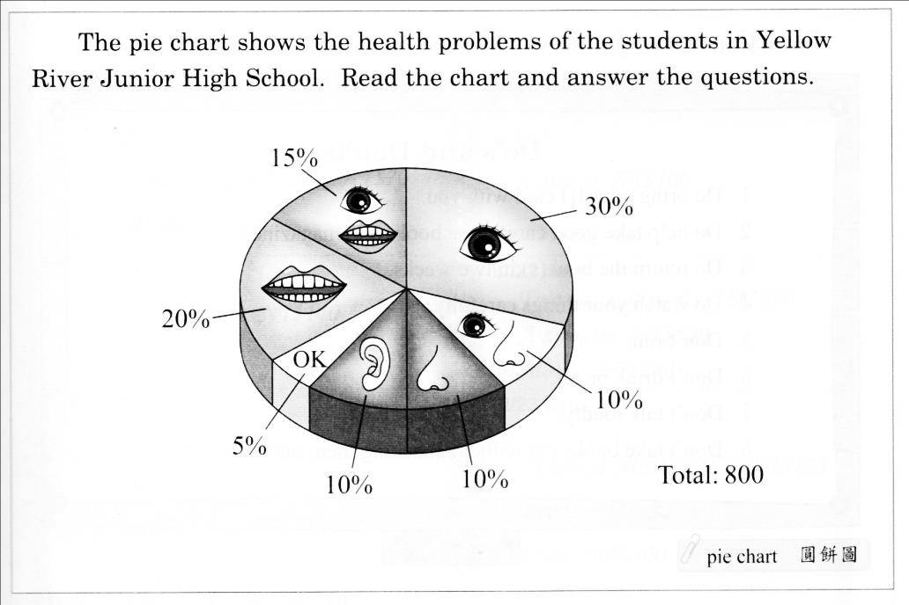【B】A Pie Chart

26. How many students in the school have no health problems?
(A) 30 (B) 40 (C) 50 (D) 60
27. How many students have problems in both eyes and teeth?
(A) 120 (B) 160 (C) 240 (D) 400
28. Which is true?
(A) 320 students have eye problems.
(B) 280 students have problems in teeth.
(C) 100 students have problems in ears.
(D) 80 students have nose problems.

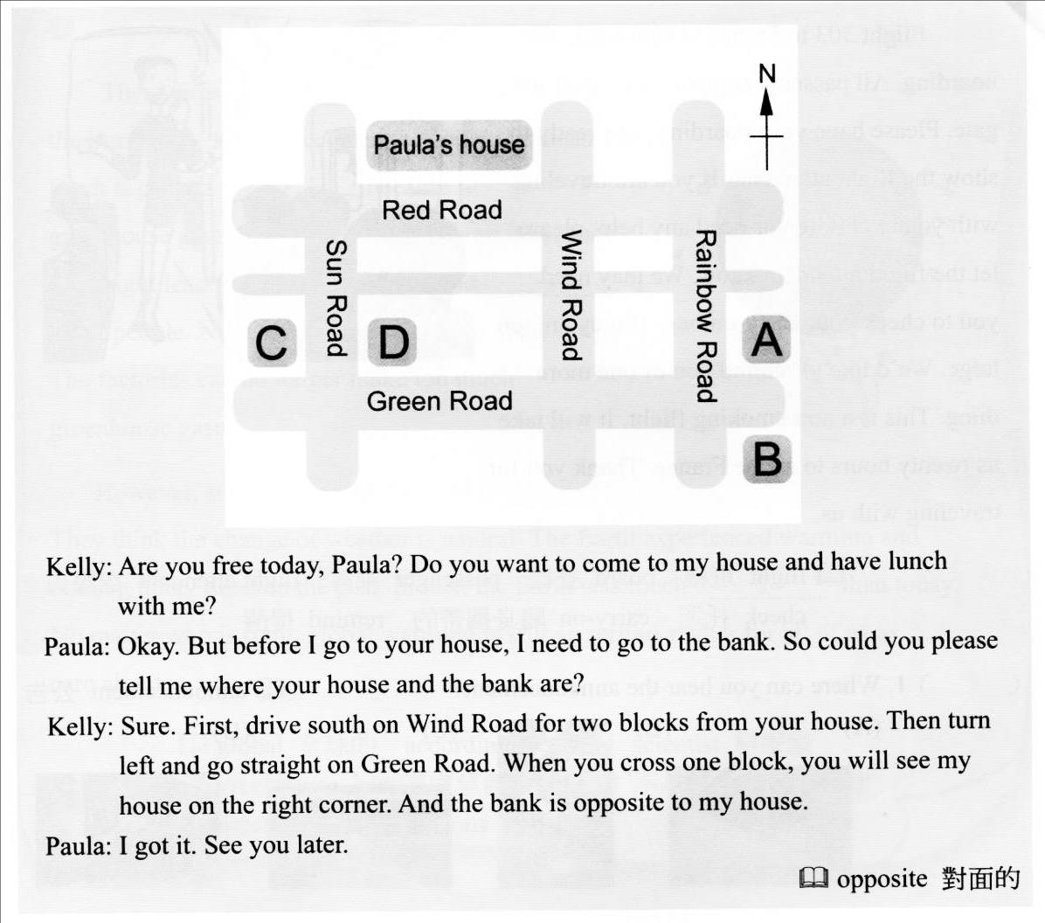【C】
South 南方 block 街區
29. How will Paula go to Kelly’s house?
(A) By car. (B) By train. (C) On the MRT. (D) By bus.
30. Where is Kelly’s house?
(A) D (B) C (C) B (D) A
31. Where is the bank?
(A) D (B) C (C) B (D) A
32. Which is true?
(A) C is the bank.
(B) D is the bank.
(C) Paula and Kelly will meet at noon.
(D) Paula isn’t free today.

【D】A Sports Meet
It’s one o’clock in the morning of Thursday, but Richard can’t sleep because he’s too excited. Every year, Richard’s school holds a sports meet. All the students attend(參加) it together. It’s Richard’s first time to join it. Tomorrow he’ll attend the 100 meters, the high jump and the long jump. At the sports meet, he can not only watch some shows but also enjoy delicious food from the food venders(攤販). It’s a big party for all the students. Richard thinks it will be great but tiring. Richard’s brother, Michael, had a great time last year. But he hurt his leg because he didn’t do warm-ups. So, he told Richard to remember to do them before the games.

33. Which is true?
(A) Richard never attends the sports meet in the school.
(B) Richard’s school holds a sports meet every month.
(C) Students can’t eat at the sports meet.
(D) Richard hurt his leg at the sports meet.
34. What does them mean?
(A) The sports meet. (B) The warm-ups.
(C) The great shows. (D) The delicious food.
35. What day is the sports meet?
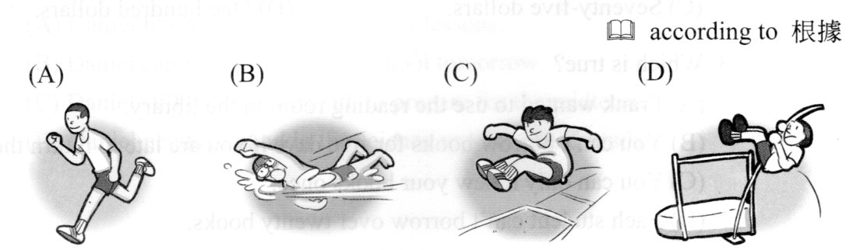(A) Thursday. (B) Friday. (C) Saturday. (D) Sunday.
36. According to reading, which sport WON”T Richard attend?
【E】Yawning
Do you often yawn? Do you often see other people yawn? When people yawn, they open their mouth, their mouth stays open for a few seconds, and they close their mouth finally.
Why do people yawn? Some people believe that we yawn because our bodies are tired and need some air. Others think that we yawn because we’re bored. However, nowadays, scientists believe people yawn to control(控制) the brain(腦) temperature(溫度).
It’s interesting to know that yawning is contagious(易感染的). When people see someone else yawn, they start yawning, too. It’s difficult for people not to yawn when someone near them is yawning. People also yawn when they read about yawning or just hear yawning. Sometimes when a person yawns, his cat, dog, or fish yawns, too.

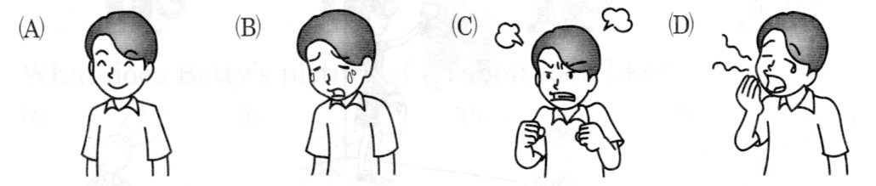37. Who is yawning?
38. Which is NOT mentioned(提到的) in the reading?
(A) People yawn when they are bored.
(B) When people feel tired, they yawn.
(C) People yawn because they are excited.
(D) People yawn to control the brain temperature.
39. What do we know about yawning?
(A) When one person yawns, it’s possible other people will yawn, too.
(B) People don’t yawn when they hear someone else yawning.
(C) Only people can yawn.
(D) People do not often yawn.
40. Which is true?
(A) People need to see a doctor when they often yawn.
(B) People close their mouth when they yawn.
(C) Yawning is not contagious
(D) Animals yawn like people do.

- 文意字彙：7%
1. Lee needs a pair of glasses because he’s n d.
2. People likes to play g ts at Halloween parties.
3. The English sentence is too difficult for me. I don’t u d it.
4. Mandy has a v n lesson this evening. She will play it with a band.
5. The parrot knows that W y is the day before Thursday. How smart!
6. Ryan left for the USA w t saying goodbye.
7. My family always has three m ls a day.

- 動詞變化(每格不限填一字)及文意填充：7%
1. Nancy needs to see the dentist because she (have) a toothache now.
2. your brother often at home in the evening?
3. My mom needs to practice (use) her new computer.
4. James: Please pass the notebook to me. Stacey: Here you .
5. Look! Someone (play) the old witch in the show.
6. What about (eat) out today? I’d like to eat pizza.
7. Students in Taiwan like to make friends people they know online.

- 翻譯：6%
1. 學生們放學後在他們的社團學習許多新東西。
2. 每班必須要在學校園遊會經營一個遊戲攤位。
3. 事實上，我不是經常每天在飯後刷牙。

天主教道明高級中學103學年度第二學期第二次段考國中一年級英語科答案卷
國中一年 班 號 姓名
- 選出最適合的答案：
- 克漏字選擇：
- 閱讀測驗：
01.DCACB
06.DAADC
11.ABDAB
16.CBBDC
21.ACDCA
26.BABAC
31.DCABB
36.BDCAD

四、文意字彙：7% |  |  | 五、動詞變化及文意填充：7%
1 | nearsighted |  | 1 | has
2 | ghosts |  | 2 | Is
3 | understand |  | 3 | using
4 | violin |  | 4 | are/go
5 | Wednesday |  | 5 | is playing
6 | without |  | 6 | eating
7 | meals |  | 7 | with
六、依提示作答及翻譯：6%
1.(The) students learn many new things at their clubs after school.
2.Every class has to run a game stand at the school fair.
3.In fact, I don’t usually brush my teeth after meals every day.

