天主教道明中學第105學年度第一學期第二次段考國中一年級英語科試題
班級：_______ 姓名：____________ 座號：_____
範圍: Unit 3～5 + Review 2
命題老師：陳岱秀
- 單字測驗：24%
- Please take the trash away. Don’t l e it here.
- 3 Idiots is a famous movie from I a. I like the actor Admir Khan very much.
- Be q t! It’s time for class.
- The shoe f s over there are Mr. Smith’s. He’s quite rich(富有).
- Taiwan is f s for its nice people and food.
- Is c te ice cream your favorite dessert(甜點)?
- The first l y in the USA is Michelle Obama(蜜雪兒˙歐巴馬).
- These two thin men are song w s. They are singers, too.
- Let’s see Doctor Strange(奇異博士) at the new movie t r.
- H y up, Joe. The school bus is coming.
- A: What is today’s s l in this restaurant? B: Fish and chips.
- Snowball and Fluffy are two p r bears from Canada.
- 文法選擇及句子對話：50% (請選出最適當的答案)
- A: Aren’t these your photos? B: No, ________.
(A) these are | (B) they are | (C) they aren’t | (D) these are not
- Peter: ________ are your mom and dad? Joe: They’re doctors.
(A) Where | (B) What | (C) Who | (D) How
- Peter: ________ is that tall young man? Joe: He’s Mr. William, my family doctor.
(A) Where | (B) What | (C) Who | (D) How
- ________ eyes are blue.
(A) Linda’s and Sam’s | (B) Linda’s and Sam | (C) Linda and Sam’s | (D) Linda and Sam
- ________ Jerry is so handsome?
(A) Why | (B) How come | (C) No wonder | (D) Why not
- ________ Jerry is so handsome.
(A) Why | (B) How come | (C) No wonder | (D) Why not
- A: Don’t open the door. B: ________.
(A) Thank you. | (B) Right. | (C) It’s all right. | (D) All right.
- Lily: ________ Jerry: Oh, I am sorry.
(A) Jerry please don’t stand here. | (B) Please, don’t stand here, Jerry.
(C) Jerry, don’t stand here please. | (D) Jerry, please don’t stand here.
- A: ________ run in the classroom. B: Why not?
(A) Let’s not | (B) Let’s no | (C) Let’s don’t | (D) Not let’s run
- A: ________ are these posters ________? B: They are from Sandy.
(A) What; for | (B) Who; for | (C) Where; from | (D) Who; from
- ________ is in the park.
(A) The women | (B) My son, Billy, | (C) Amy and I | (D) The men
- Is ________?
(A) that writer heavy | (B) that heavy a writer | (C) that a writer heavy | (D) that heavy writer
- A: ________ you come from the UK? B: Yes, I ________.
(A) Do; am | (B) Do; do | (C) Are; do | (D) Are; am
- A: Isn’t ________ in town? B: No, he is out of town. 選出「錯誤的」選項
(A) dad | (B) your dad | (C) the girl’s dad | (D) Dad
- Turn ________. 選出「錯誤的」選項
(A) off the phone | (B) the phone off | (C) off it | (D) it off
- A: I am a waiter. What about you? B: ________
(A) I am too. | (B) I am not, either. | (C) So I am. | (D) So am I.
- Hello, everyone! Welcome ________ Taiwan.
(A) x | (B) in | (C) at | (D) to
- Sara ________ nice to her classmates.
(A) is | (B) be | (C) don’t | (D) don’t be
- David, ________ nice to your sister.
(A) is | (B) be | (C) don’t | (D) don’t is
- The computer is ________ my grandfather for my birthday.
(A) to | (B) in | (C) from | (D) for
- Ms. Chen’s daughter, Tiffany, is ________ girl.
(A) a eleven-year-old | (B) an eleven years old | (C) a one-year-old | (D) an one year old
- A: ________ is ________ age ? B: He is twelve.
(A) What; Ken’s | (B) How; Ken’s | (C) How; Ken | (D) What; Ken
- A: Are you Tom’s ________ brother? B: Yes, we are _________. Our mom is Helen.
(A) twins; twins | (B) twin; twins | (C) twin; twin | (D) twin’s; twins
- Listen to ________ and stop talking.
(A) I | (B) my | (C) me | (D) we
- These ________ voice is sweet and beautiful.
(A) actress’s | (B) actress’ | (C) actresses’s | (D) actresses’
- 閱讀測驗：20%
 | Hello, everyone. My name is Christina. I’m the pastry chef at Pappa Bear in Taiwan. And I’m from France. I can make favorite banana cakes, apple pies, and cheese puffs.
 | Hi, I’m Paul. I’m a salesman from Canada. I’m an inventor, too. My robots can talk and run. They are cool and special. I make them and sell them. Come and see those robots at www.paulrobot.com.tw.
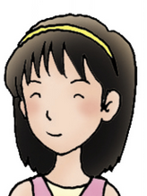 | Hi, my name is Yuki. I’m a student in Taiwan. But I’m from Japan. My family aren’t with me. They are in Japan.
pastry chef 點心師傅 puff 泡芙 inventor 發明家 sell 販售
- What / Who are “them”?
(A) Paul’s robots. | (B) Christina, Yuki, and Paul. | (C) Christina’s puffs. | (D) Yuki’s family.
- Where is the pastry chef from?
(A) Canada. | (B) France. | (C) Japan. | (D) Taiwan.
- Which one is true?（何者正確？）
(A) People can see Paul’s robots at Pappa Bear. | (B) Yuki and her family are from the ROC.
(C) Paul is a salesman from Canada. | (D) Christina and Paul are from the same country(國家).

Bigfoot
Bigfoot has long arms and long legs.
His hair is long, too.
His eyes and ears are small.
Bigfoot doesn’t have a big head.
But he has big hands and big feet.
Look at his feet.
They’re about 40 centimeters long.
Aren’t they big? centimeters 公分
- How are Bigfoot’s arms and legs?
(A) His arms are short, but his legs are long. | (B) His arms are short, and his legs are short, too.
(C) He has long arms, but he doesn’t have long legs. | (D) His arms and legs are long.
- Which is true about Bigfoot?
(A) His head is big. | (B) He has big ears.
(C) He has long hair. | (D) He is forty centimeters tall.
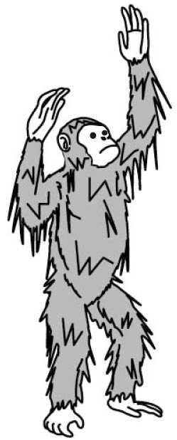
- Which is Bigfoot?
(A)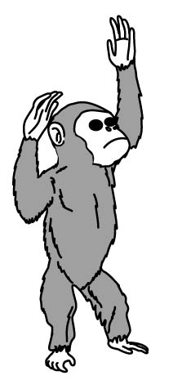 (B)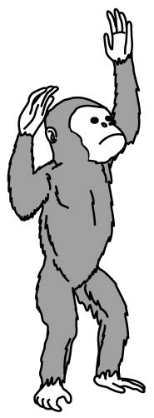 (C)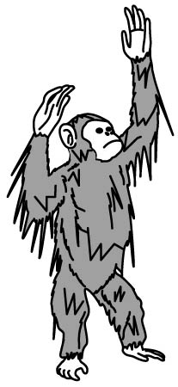 (D)

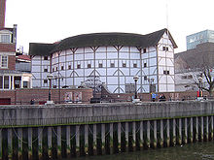
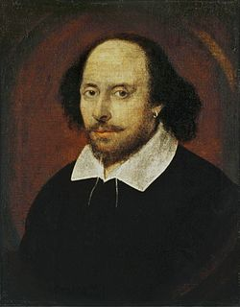
People say William Shakespeare was one of the world’s greatest writers. He wrote many plays and poems. His writings are all over 400 years old now. One of his most famous plays is Hamlet. Although they are really old, people still love them. Shakespeare left school when he was 16. Afterwards, he went to London. He became an actor around 1590. He also started writing plays then. By 1598, Shakespeare was famous. He and some other actors started their own theater. It was called the Globe.

- Which of the following is NOT said about William Shakespeare?
(A) He was born in a family full of actors. | (B) He was a writer over 400 years ago.
(C) He wrote many poems. | (D) He wrote many plays.
- What happened when William Shakespeare was 16 years old?
(A) He wrote his first poem. | (B) He stopped going to school.
(C) He left his home in London. | (D) He built a theater.
Jerry  Mom: Jenny  Dad: Victor  Job: baseball coach  Age: 25 | Adam  Mom: Coco  Dad: William  Job: student  Age: 14 | Ella  Mom: Joan  Dad: Mark  Job: housewife  Age: 32 | Rita  Mom: Jenny  Dad: Victor  Job: writer  Age: 35

- Who is Joan?
(A) Victor’s sister. | (B) Rita’s mother. | (C) William’s student. | (D) Mark’s wife.
- ________ are brother and sister.
(A) Jerry and Rita | (B) Ella and Adam | (C) Jenny and Mark | (D) Coco and William
- 翻譯題：6%
- 在公車上，請遵守這些規則並且不要製造噪音。(Please…)
- 這是我們要到巧克力工廠的校車。
- Bob, /not/wait/me. (可加入單字以完成句子)

天主教道明中學第105學年度第一學期第二次段考國中一年級英語科答案紙
班級：_______ 姓名：____________ 座號：_____
範圍: Unit 3～5 + Review 2
(請用黑或藍色筆作答; 鉛筆作答者一律扣20分、未填姓名座號者扣10分)

- 單字測驗：24% (請寫出完整的單字)
1 |  | 2 |  | 3 |  | 4
5 |  | 6 |  | 7 |  | 8
9 |  | 10 |  | 11 |  | 12

- 文法選擇及句子對話：50% (請在小框欄中將正確答案用原子筆打勾ˇ)
 | 1 | 2 | 3 | 4 | 5 | 6 | 7 | 8 | 9 | 10 | 11 | 12 | 13 | 14 | 15 | 16 | 17 | 18 | 19 | 20 | 21 | 22 | 23 | 24 | 25
A | □ | □ | □ | □ | □ | □ | □ | □ | □ | □ | □ | □ | □ | □ | □ | □ | □ | □ | □ | □ | □ | □ | □ | □ | □
B | □ | □ | □ | □ | □ | □ | □ | □ | □ | □ | □ | □ | □ | □ | □ | □ | □ | □ | □ | □ | □ | □ | □ | □ | □
C | □ | □ | □ | □ | □ | □ | □ | □ | □ | □ | □ | □ | □ | □ | □ | □ | □ | □ | □ | □ | □ | □ | □ | □ | □
D | □ | □ | □ | □ | □ | □ | □ | □ | □ | □ | □ | □ | □ | □ | □ | □ | □ | □ | □ | □ | □ | □ | □ | □ | □

- 閱讀測驗：20%
 | 1 | 2 | 3 | 4 | 5 | 6 | 7 | 8 | 9 | 10
A | □ | □ | □ | □ | □ | □ | □ | □ | □ | □
B | □ | □ | □ | □ | □ | □ | □ | □ | □ | □
C | □ | □ | □ | □ | □ | □ | □ | □ | □ | □
D | □ | □ | □ | □ | □ | □ | □ | □ | □ | □

- 翻譯: 6%

天主教道明中學第105學年度第一學期第二次段考國中一年級英語科答案

範圍: Unit 3～5 + Review 2
(請用黑或藍色筆作答; 鉛筆作答者一律扣20分、未填姓名座號者扣10分)

一.單字測驗：24% (請寫出完整的單字)
1 | leave | 2 | India | 3 | quiet | 4 | factories
5 | famous | 6 | chocolate | 7 | lady | 8 | writers
9 | theater | 10 | Hurry | 11 | special | 12 | polar

- 文法選擇及句子對話：50% (請在小框欄中將正確答案用原子筆打勾ˇ)
 | 1 | 2 | 3 | 4 | 5 | 6 | 7 | 8 | 9 | 10 | 11 | 12 | 13 | 14 | 15 | 16 | 17 | 18 | 19 | 20 | 21 | 22 | 23 | 24 | 25
A | □ | □ | □ | √ | □ | □ | □ | □ | √ | □ | □ | √ | □ | √ | □ | □ | □ | √ | □ | □ | □ | √ | □ | □ | □
B | □ | √ | □ | □ | √ | □ | □ | □ | □ | □ | √ | □ | √ | □ | □ | □ | □ | □ | √ | □ | □ | □ | √ | □ | □
C | √ | □ | √ | □ | □ | √ | □ | □ | □ | □ | □ | □ | □ | □ | √ | □ | □ | □ | □ | √ | √ | □ | □ | √ | □
D | □ | □ | □ | □ | □ | □ | √ | √ | □ | √ | □ | □ | □ | □ | □ | √ | √ | □ | □ | □ | □ | □ | □ | □ | √

- 閱讀測驗：20%
 | 1 | 2 | 3 | 4 | 5 | 6 | 7 | 8 | 9 | 10
A | √ | □ | □ | □ | □ | □ | √ | □ | □ | √
B | □ | √ | □ | □ | □ | □ | □ | √ | □ | □
C | □ | □ | √ | □ | √ | □ | □ | □ | □ | □
D | □ | □ | □ | √ | □ | √ | □ | □ | √ | □

- 翻譯: 6%
- Please follow the rules /and don’t make noise on the bus.
- This is our school bus/ to the chocolate factory.
- Bob, don’t/ wait for me.

