天主教道明高級中學106學年度第一學期第二次段考國中一年級英語科試卷
(範圍：康軒版B1 L3~Review2) 本份試題共52題，請仔細作答
- 選出最適合的答案：40 %
  - Sue is a junior high school student, and _____ am I.
(A) so (B) too (C) also (D) either
  - Sherry is ________ girl.
(A) an one year old (B) an eight-year-old
(C) an eighteen years old (D) a nine-years-old
  - Cindy: ______ your sisters’ ages?
James: Lily is five, and Amy is six.
(A) How old is (B) How are
(C) How old are (D) What are
  - Sherry: ____
Terry: India.
(A) Where is your father come from? (B) Your mother come from where?
(C) Where do you come from? (D) Is your family from India?
  - Sam and Connie are ____ .
    - a brother and a sister (B) brother and sister
(C) brothers and sisters (D) a brother and sister
  - Everyone on the school bus ______ tall.
(A) does (B) are (C) am (D) isn’t
  - Ada: Who’s the boy? Bob: _______. (Choose the WRONG answer)
(A) He’s Harry. (B) The boy is my student.
(C) He’s the prince. (D) The boy isn’t a baseball player.
  - Choose the WRONG answer
(A) Is this a nice pen? (B) Are those boys short?
(C) Is that cute puppy? (D) Are these your favorite posters?
  - The robot is cool _______ good.
(A) and (B) also (C) too (D) or
  - Tammy, are______ in the park?
(A) daddy and mommy (B) Mom and Dad
(C) your Mom and Dad (D) mom and dad
  - Nice to meet you, _______. (Choose the WRONG answer)
(A) Mr. Peter (B) sir
(C) Ms. Nancy Lin (D) madam
  - A: Isn’t Tom a tall boy? B: No, _____.
(A) he is tall (B) he is short
(C) he is (D) Tom isn’t

  - His brother isn’t thin, but his sisters _______.
(A) is (B) do (C) aren’t (D) are
  - Choose the RIGHT answer.
(A) Nice to see you, Sir.
(B) This two boy’s mother is short.
(C) Those pets cats are yellow and cute.
(D) The girls’ school is big and beautiful.
  - I, your aunt’s daughter, _______ a good student.
(A) be (B) is (C) am (D) are
  - _____ get _____ the taxi.
(A) Let’s not; on (B) Don’t let us; on
(C) Let’s don’t; in (D) Let us not; in
  - Your cellphone is ringing(響). Please ________.
(A) turn it off (B) turn off it
(C) close it (D) open it
  - Choose the WRONG answer.
(A) Please stand up, Peter.
(B) Joe, be quiet, please.
(C) Sit down, David, please.
(D) Ted, please smile.
  - Sydney, ______ a nice girl.
(A) is (B) does (C) be (D) to be
  - The teacher said to her students, ” be late for class.”
(A) Always (B) Never (C) Let us (D) Not

- 克漏字選擇：16 %
【A】
Frank: What a cute dog! 21
Jenny: I’m not sure.
Frank: You can take him to the vet and he will tell you the answer.
Jenny: 22 does the vet do it?
Frank: By checking his teeth and doing other exams. By the way, 23
Jenny: Yes. He sleeps with me, so I do it every day.
Frank: Oh, my. That’s not good for the dog. Once a month is enough.
Jenny: Really? You know a lot about dogs. Thanks for telling me.
Frank: 24
※ vet 獸醫 exam 檢驗測試 once 一次 enough 足夠
21. (A) What can he do? (B) What’s his name?
(C) How old is he? (D) Where is he from?
22. (A) How (B) Where (C) Why (D) What
23. (A) Do you take him to the vet? (B) Do you wash him?
(C) Do you walk him in the park? (D) Do you brush his teeth?
24. (A) Welcome! (B) Where! Where!
(C) I’m the best! (D) Glad I can help!

【B】
Jane: Who’s that man?
Ben: The 25 man?
Jane: No, the short man.
Ben: Oh, that’s Clark Kent. He’s our new boss.
Jane: Wow. Superman’s name is Clark Kent, 26 .
Ben: Yes, but they are very different.
Jane: 27
Ben: Our boss is 28 and heavy. Superman is young and handsome.
Jane: Haha…. Oops!
Clark: Good morning, everyone!
25. (A) big (B) high (C) tall (D) small
26. (A) too (B) to (C) also (D) right
27. (A) Who? (B) How come? (C) How old? (D) Where?
28. (A) cool (B) special (C) thin (D) old

- 閱讀測驗：34%
【A】Please look at the pictures and answer the questions.
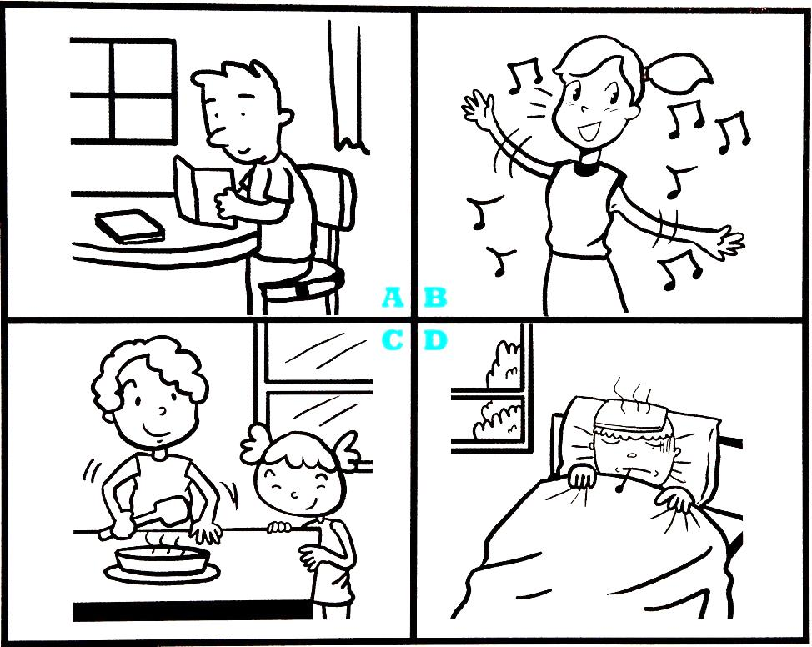

29. Mark: Why isn’t your brother at school today?
Amy: He has a bad cold and has to stay in bed today.
(A) A (B) B (C) C (D) D
30. Tim: Who’s that girl singing over there?
Gary: I don’t know, but she’s very beautiful.
(A) A (B) B (C) C (D) D
31. Mom: Where’s your brother?
Lily: He’s studying in the room.
(A) A (B) B (C) C (D) D

【B】
Hi! My name’s Craig. I’m a junior high school student. There are many people in my family. I live with my dad, my mom, and my brother, Ian. Ian is only three.
Todd, a senior high school student, is the only son of Uncle Frank and Aunt Dolly. In my free time, I often go to his home and play online games with him.
Todd and I also visit our grandparents’ house often because we both like Uncle Victor very much. He’s the youngest child of our grandparents. He’s a funny math teacher and often helps us with our math homework.
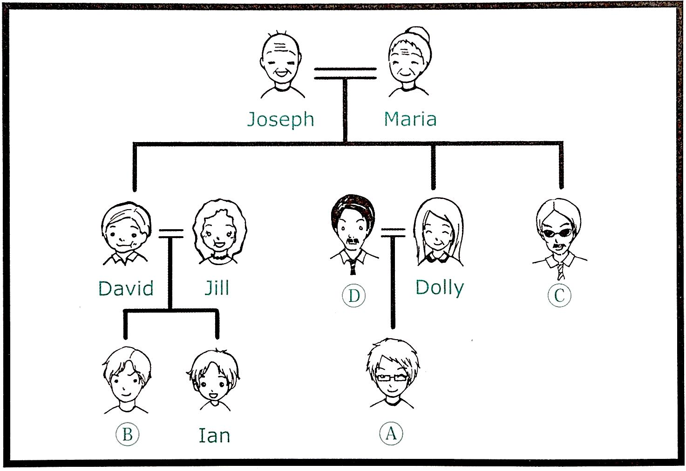

32. Look at Craig’s family tree. Which one is Victor?
(A) A (B) B (C) C (D) D
33. Look at Craig’s family tree. What is my mother’s name?
(A) Dolly. (B) David. (C) Jill. (D) Maria.
34. Todd and Craig are .
(A) brothers (B) sisters (C) cousins (D) classmates
35. According to the family tree, how many sons do Craig’s grandparents have?
(A) Two. (B) Three. (C) Four. (D) Five.

【C】Read David’s class rules and answer the questions.

Class Rules
- Listen to English CD for an hour at home every day.
- Take notes in class.
- Study English for thirty minutes at school every day.
- Clean the classroom from 7:30a.m. to 8:00a.m.
- Do the homework at home.
- There is no eating or sleeping in class.
- There is no shouting or running in the classroom.
- There is no video game playing at school.

＊ take notes 作筆記 must 必須 at least 至少
36. According to the class rules, what can students do in class?
(A) Sleep. (B) Shout. (C) Take notes. (D) Eat.
37. According to the class rules, how many things MUST students do before school?
(A) One. (B) Two. (C) Three. (D) Four.
38. According to the class rules, how long does David learn English every day?
(A) 30 minutes. (B) 60 minutes. (C) 90 minutes. (D) 120 minutes.

【D】Read the following passage and answer the questions.
Studying is important, but studying wisely is even more important. First, study at the right time. Don’t stay up too late studying because you’ll be too tired to remember what you have read. And if you study for too long, you’ll remember nothing and feel exhausted. What should you do if you are exhausted? One good idea is to leave the place where you are studying and go out for a walk, or do something to wake yourself up. You’ll feel much better when you get back to your study again.
＊ wisely 明智地 too…to 太…而不能 wake 喚醒
39. What can you do if you’ve been studying for too long?
(A) Keep on studying. (B) Eat a snack.
(C) Go for a walk. (D) Call some friends.
40. Which of the following words means the same as “exhausted”?
(A) Happy. (B) Sad. (C) Hungry. (D) Tired.

41. What is the main idea of this reading?
(A) Some tips to help you study better.
(B) Stay up to study if you need to.
(C) You need a healthy body to study well.
(D) Never leave your desk when you are studying.

【E】Read the following letter and answer the questions.
Dear Tina,
Long time no see. How’s school in Kaohsiung? I’m fine here in Taipei. But we are moving to Hsinchu next month.
I pack things in boxes every day. It’s tiring. But I find many interesting things. Do you still remember Ahala the doll? It was a gift from my aunt from New York. She has a big head, long hair, two big eyes, and there are bees on her dress. She was our sister when we played house. It was a wonderful time. Now we go to different schools and live in different places. I really miss you.
I’m sending you the doll. I think you will be happy to have it. I hope we’ll always be friends.
Diana
42. Where is Diana?
(A) In New York. (B) In Kaohsiung.
(C) In Hsinchu. (D) In Taipei.
43. Which is the doll Ahala?
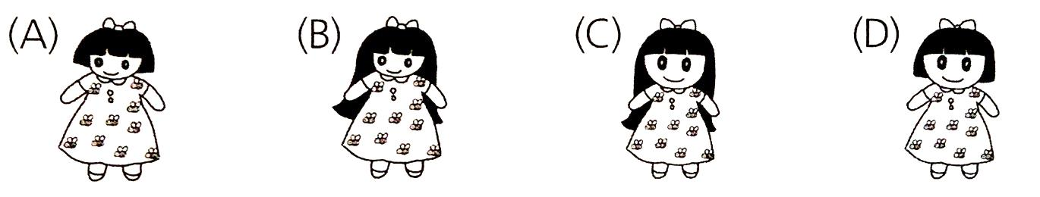
44. Why does Diana write to Tina?
(A) To ask her not to move.
(B) To tell her she wants to give her the doll.
(C) To ask her to look for the doll.
(D) To talk about their sister.

【F】Barking Dogs Never Bite
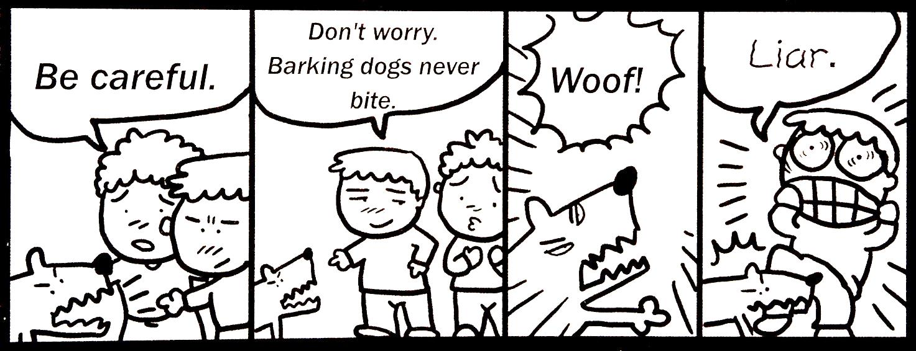
45. According to the story, which is true?
(A) A barking dog never bites.
(B) Sometimes, a barking dog bites.
(C) The dog is their friend.
(D) The dog isn’t barking.

- 文意字彙：4%
46. Tina is a good s r. She’s like(像) a fish.
47. Jay is a great singer, and he’s very p r with the young.
48. Tom and Bill are car s n. They work in that car company(公司).
49. Mandy is a q t girl. She seldom(很少) talks.

- 翻譯：6%
50. 電影院裡好黑。(It …..)
51. 我們去才藝表演秀吧!
52. 這間學校以什麼而著名？

- 測驗結束，請再次檢查，確認作答後繳交。

天主教道明中學106學年度第一學期第二次段考國一英語科答案卷
班級________ 座號_________ 姓名___________________

一、選出最適合的答案(每題2分)
1. ABDCB 6. DDCAB
11. ABDDC 16. DACCB

二、克漏字選擇(每題2分)
21. CABD 25. CABD

三、閱讀測驗(每題2分)
29. DBA 32. CCCA 36. CBC
39. CDA 42. DCB 45. B

四、文意字彙 (每題1分)

46. swimmer | 47. popular | 48.salesmen | 49.quiet

五、翻譯 (每題2分)

50. It’s (very) dark in the movie theater.

51. Let’s go to the talent show!

52. What is this/the school famous for?

