天主教道明高級中學106學年度第二學期第三次段考國中一年級英語科試卷
(範圍：康軒版B2，圖表解構超強英文閱讀U11-15) 本份試題共50題，請仔細作答

- 選出最適合的答案：44 %
  - Choose the WRONG sentence.
(A) How many bags of beef does Nancy buy?
(B) How much pork is there in the refrigerator?
(C) How many sheeps are there on the farm?
(D) How many old photographs do you have?
  - Everything in Green Field _____ very beautiful at that time.
(A) is (B) does (C) can (D) was
  - Which does Cathy need, _____ or _____?
(A) ruler; marker (B) a ruler; marker
(C) rulers; markers (D) rulers; marker
  - Cindy ____ short then, but she ___ tall now.
(A) was; was (B) was ; is
(C) is; is (D) is; isn’t
  - Bryant: _____ the ball pens?
Vivian: Twenty dollars.
(A) How many dollars are (B) How many
(C) How much money is (D) How much
  - Do we need ______?
(A) what else (B) anything else
(C) special anything (D) somethings good
  - Mom and Dad always buy ______fruit and vegetables on the weekend.
(A) much (B) many (C) any (D) a lot of
  - Let’s ______.
(A) buy it David (B) buy it for David
(C) buy David it (D) buy David to it
  - Sean was just a three-year-old boy ______. (Choose the WRONG answer)
(A) long time before (B) a year ago
(C) at that time (D) the day before yesterday
  - Sarah is poor and needs our help. She only has ______ friends and _____ money.
(A) many; much (B) a few; a little
(C) some; any (D) few; little
  - _____ you or Bella at home?
(A) Aren’t (B) Can (C) Isn’t (D) Do
  - There shouldn’t ______ any trash in our classroom.
(A) to be (B) be (C) have (D) has
  - We need _____ for the party.
(A) one kilo of the pork
(B) six pounds beef
(C) eight bottles of apples juice
(D) nine slices of cheese
  - _____ eat out this evening? I’d like to go to the new restaurant.
(A) What about (B) Let’s not
(C) Why not (D) How often
  - Choose the CORRECT sentence.
(A) Always get up early, Brad, please.
(B) Sometimes Peter goes to school late.
(C) Please never late for work, James.
(D) Lynn doesn’t always busy at school.
  - Adam: _________
Eve: It’s on Friday, June 8.
(A) What time is it now? (B) What date is it today?
(C) What day is today? (D) What’s the date of your talent show?
  - Those boy students usually play baseball _____. (Choose the WRONG answer)
(A) on Tuesday afternoons (B) at six p.m. on Tuesdays
(C) on every Tuesday (D) on the evening of Tuesday
  - _____ you roller-skate?
(A) Do not (B) Cannot (C) Can’t (D) Aren’t
  - Sydney _____ here in the morning, but we _____.
(A) is dancing; aren’t (B) doesn’t dance; do
(C) dances; dance (D) can dances; cannot
  - Joe _____. (Choose the WRONG answer)
(A) helps her finishing the work
(B) helps him with the housework
(C) helps his mother do the dishes
(D) helps me to do my homework
  - Ben never remembers his hands before meals.
(A) washes (B) wash
(C) to wash (D) is washing
  - Add some water the soup. The soup is too salty.
(A) for (B) with
(C) to (D) by

- 克漏字：16 %
【A】
You use it every day. In fact, you can’t live 23 it. It’s found all over the earth. Most of the time people see it 24 a liquid, but it 25 also be a solid or a gas --- like ice, snow, or steam. It’s a part of living things. Living things would die if they don’t have it.
It can also be used in millions of ways to make things work better, to cool things, to clean things, and to make heat and power.
It is 26 that we use every day.
※ liquid 液體 solid 固體 steam 蒸氣 living things 所有的生物
23. (A) at (B) without (C) with (D) by
24. (A) in (B) as (C) on (D) of
25. (A) must (B) need (C) will (D) can
26. (A) water (B) salt (C) air (D) sugar

【B】
Clerk: May I help you?
Lydia: Yes! 27 the price of that pink dress in the shop window?
Clerk: Hmm, let me check…There’s a ten percent discount now, so it’s $3600.
Lydia: Oh! That’s still expensive, even with the discount. I wonder if you have 28 cheaper?
Clerk: Well, here’s a nice dress for $1000. I think it would look great on you.
Lydia: Can I 29 it 29 ?
Clerk: Sure. What size do you wear?
Lydia: I wear a size 38.
Clerk: We have that size. You can use the fitting room there.
(Ten minutes later, Lydia walks out the fitting room.)
Lydia: Okay! It fits me well. I will 30 it

27. (A) What’s (B) How’s (C) Why’s (D) Where’s
28. (A) everything (B) something (C) else (D) things
29. (A) cut; off (B) pick; up (C) try; on (D) put; away
30. (A) give (B) sell (C) make (D) take

- 閱讀測驗：40 %
【A】
Today is Friday. Two days ago, Neil received the result of the math test he took this Monday. He got a low grade. Neil’s math teacher wants to speak with his parents. But Neil’s father is on a business trip and won’t be back until next Tuesday. So Neil has to wait several days before telling his father about his bad grade. Neil feels very nervous.
※ on a business trip 出差

31. Which day of the week did Neil find out the result of his math test?
(A) Tuesday (B) Wednesday (C) Friday (D) Saturday
32. If today is June 10, when did Neil take the math test?
(A) On June 9. (B) On June 2.
(C) On June 6. (D) On May 30.
33. How many days does Neil have to wait until his father returns?
(A) Six days (B) One day
(C) Two days (D) Four days

【B】
Deep Water Divers
Diving Prices | Adults | Students/ Seniors
One Dive | $20 | $18
Two Dives | $35 | $30
Two Dives with Lunch | $45 | $40
Suit Rentals | $12 | $10

We will leave for dives at 8:00 a.m. To dive, you must bring your ID. No beginners! If you don’t feel well, please tell the diving coach. We will let you dive at another time or on a different day. Remember that you may only dive two times a day.

※ diver 潛水者 suit 潛水服 rental 出租 senior 年長者 ID 身分證件
34. Carol is 35. She wants to dive on Friday morning and afternoon, but she doesn’t take her own lunch and diving suit. How much will she have to pay?
(A) Fifty-seven dollars (B) Forty-five dollars
(C) Thirty-five dollars (D) Twenty dollars
35. Barry has never dived before. What will the diving coach tell him?
(A) You should come at 8:00. (B) Please bring your ID.
(C) Sorry, you can’t dive. (D) You must rent a diving suit.
36. Which of the following is NOT true?
(A) People who do not feel good can get their money back.
(B) There’s a limit to the number of dives in a day.
(C) Deep Water Divers will not give out free lunches.
(D) It costs the same price for old people and students to dive.

【C】
How does the animal,
Wave his beautiful long tail,
And drink the water of the river,
Under the beautiful sunshine?

How wildly he smiles!
How quickly he spreads his claws,
And welcomes little fishes in,
With his smiling jaws!

※ wildly 狂野地 spread 伸展 claw 爪子 jaw 下巴
37. What does the animal mean?
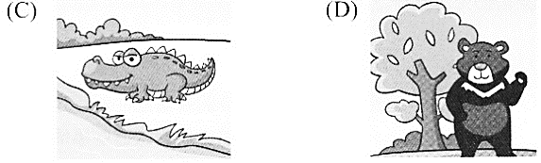
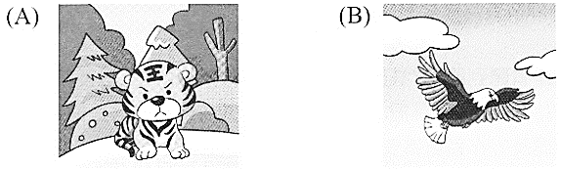

38. Why does the animal need to welcome fish in with his jaws?
(A) He enjoys smiling at all kinds of animals in the river.
(B) He wants to be friends with little fish.
(C) His mouth is hurt, and these fish are doctors.
(D) He wants to eat them all, or he may feel hungry.
39. Which is NOT true about the animal in the poem? ＊ poem 詩
(A) He drinks the water from the river.
(B) He opens his mouth wildly to let fish swim in.
(C) He has a long tail and claws.
(D) He never smiles, so he looks terrible.

【D】
Do you often yawn? Do you often see other people yawn? When people yawn, they open their mouth, their mouth stays open for several seconds, and then they close their mouth.
Why do people yawn? Some people believe that we yawn because our bodies are tired and need some air. Others think that we yawn because we’re bored. For example, when students aren’t interested in what their teachers are saying, they yawn a lot. However, nowadays, scientists believe people yawn to control brain temperature.
It’s interesting to know that yawning is contagious. When people see someone else yawn, they start yawning, too. In fact, it’s difficult for people not to yawn when someone near them is yawning. People also yawn when they read about yawning or just hear yawning. Sometimes when a person yawns, his cat, dog, or fish yawns, too.
Isn’t it interesting to learn about yawning?
※ nowadays 現今 control 控制 brain 腦 temperature 溫度 contagious 容易傳染的

40. Who is yawning?
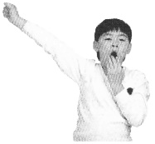
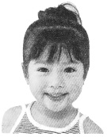
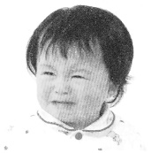
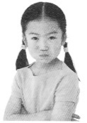
(A) (B) (C) (D)

41. Which is NOT mentioned in the reading? ＊ mention 提及
(A) People yawn to control brain temperature.
(B) People yawn when they are bored.
(C) People yawn because they are excited.
(D) When people feel tired, they yawn.
42. What can we learn about yawning?
(A) People do not yawn when they hear someone else yawning.
(B) When one person yawns, it’s possible other people yawn, too.
(C) Only people can yawn.
(D) People do not often yawn.

【E】
Montreal is the second largest city in Canada. It’s a beautiful and safe city, so people from all over the world move there. Look at the following graphs to learn more about Montreal.
Graph 1---Where do the immigrants in Montreal come from?
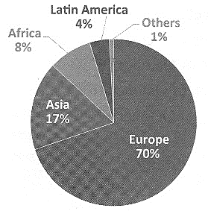

Graph 2---Which mother language do people in Montreal speak?
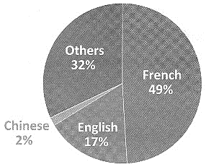

※ graph 圖表 immigrant 移民
43. There are about 0.6 million immigrants in Montreal. How many of them are from Asia?
(A) More than 0.4 million people.
(B) Fewer than 0.04 million people.
(C) About 0.05 million people.
(D) About 0.1 million people.
44. A reporter writes the following passage after he takes a trip to Montreal. What does in the passage mean? ＊ passage 段落
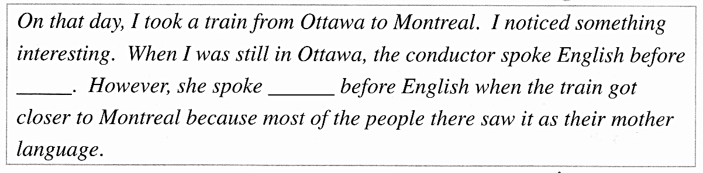
(A) Other languages. (B) French.
(C) Chinese. (D) English.
45. Which is NOT true about Montreal?
(A) It’s the second largest city in Canada.
(B) 70% of its immigrants are from Europe.
(C) About 2% of people speak Chinese at home.
(D) Only 32% of people speak English as their mother language.

【F】
Rice is an important food in Taiwan. Farmers grow rice on the farm in many parts of Taiwan. They grow rice by hands and machine. It takes them a lot of hard work to grow rice.
People in Taiwan eat rice almost every day. It’s easy to cook rice. First, wash the rice. Then, put it in a cooking pot, add some water, and cook it in a rice cooker. Many rice cookers keep the rice warm after it is cooked, so people can have it at any time of the day.
Most people in Taiwan have white rice, but now more and more people have some brown rice as well. White rice tastes better, but it’s not so nutritious as brown rice. However, brown rice is more expensive than white rice. It’s a good idea to mix white rice and brown rice while you cook.
People in Taiwan live on rice. They cannot live without rice.
- crop 農作物 nutritious 營養的 than 比
46. Which is a rice cooker?
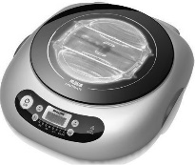
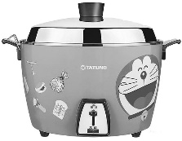
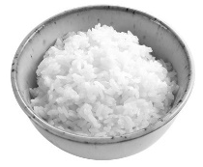
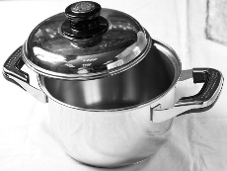
(A) (B) (C) (D)

47. Which is true?
(A) Brown rice is cheaper than white rice.
(B) Brown rice is becoming more popular than before.
(C) Brown rice tastes better than white rice.
(D) It’s wrong to mix white rice with brown rice.

48. What can we learn from the reading?
(A) It’s easy to grow rice.
(B) We can see many rice farms in many places in Taiwan.
(C) Only some people in Taiwan eat rice every day.
(D)Farmers in Taiwan grow rice only by hand.

【G】
Mary is learning western table manners in Ms. Wu’s class. Today she learned how to set the table in class. Look at Mary’s notes and answer the questions.
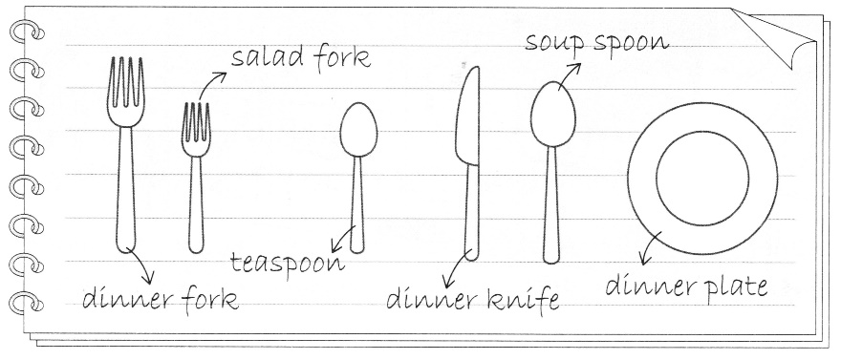
Setting the table:
- Put the dinner plate on the table in front of the chair.
- To the left of the plate, place the salad fork on the outside, and the dinner fork on the inside.
- Put the dinner knife next to the plate on the right, and the soup spoon beside it.
- western 西方的 manners 禮儀

49. According to Mary’s note, which picture shows how to set the table? ＊ according to 根據
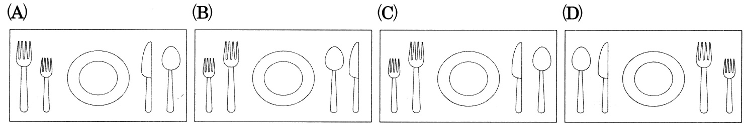

50. Which did Mary NOT put on the table?
(A) A soup spoon.
(B) A teaspoon.
(C) A salad fork.
(D) A dinner plate.

- 測驗結束，請再次檢查，確認作答後繳交。

天主教道明中學106學年度第二學期第三次段考國一英語科答案卷
班級________ 座號_________ 姓名___________________

一、選出最適合的答案(每題2分)
1. CDCBA 6. BDBAD
11. ABDCB 16. DCCBA
21. CC

二、克漏字選擇(每題2分)
23. BBDA 27. ABCD

三、閱讀測驗(每題2分)
31. BCD 34. ACA 37. CDD
40. ACB 43. DBD 46. CBB
49. CB

