天主教道明中學第109學年度第一學期第一次段考二年級英文科試卷
命題老師：國二教師群
- 單字填空：12% (請於答案紙上，用黑或藍筆寫出完整的單字。)
- Peter b_______ned because he ate too many sweets. He can eat eight cakes at a time. Maybe he needs to go on a diet.
- I went camping by the river. It was a great e_______e. I want to go there again.
- There are many ways to learn English. You can do it t_______h English songs or movies.
- Andy b_______t a basket of fruit to his grandmother in the hospital.
- Miss Huang is nice and kind. She t_______ts her students like her children.
- The road to the airport was so busy that we were a_______d of missing the plane.
- 選擇題：(1~30:2% ;31~50:1% ) 80%
- Lily _______ breakfast for her parents every day last month.
(A) prepare | (B) prepares | (C) prepared | (D) is preparing
- A: I met Debby this morning. B: Really? How_______ she?
(A) did | (B) does | (C) were | (D) was
- A: Who _______ the classroom? B: Helen did.
(A) cleaned | (B) cleans | (C) clean | (D) is cleaning
- A: May I _______ to Tom please? B: He is not here now. Please call him later.
(A) tell | (B) say | (C) chat | (D) speak
- Cindy enjoys jogging and _______ to music at the same time.
(A) to listen | (B) listens
(C) listening | (D) listen
- The meeting lasted _____ almost four hours, and nobody was happy about it.
(A) for | (B) on | (C) in | (D) at
- A: Isn’t the library _______ to your school? B: Yes, it is. But it is _______ on Mondays.
(A) closed ; closed | (B) closed ; close | (C) close ; close | (D) close ; closed
- The festival last month _______ so much fun. We want to come again next year.
(A) had | (B) has | (C) is | (D) was
- Simon is a _______. He always gets really mad when he loses a game.
(A) sore headache | (B) sore throat | (C) sore loser | (D) strong stomach
- My mom _______me an interesting story before I went to bed last night.
(A) said | (B) spoke | (C) told | (D) talked
- Jerry made a card for his teacher, Miss Lu yesterday. He will send _______ tomorrow.
(A) it to her | (B) it for her | (C) her it | (D) it her
- My shoes are not _______ my sister’s. My shoes are red, and _______ are yellow.
(A) same with ; her | (B) the same as ; hers
(C) the same with ; her | (D) same as ; hers
- I have two uncles, Jay and Jason. Jay is so serious, and he seldom smiles. _______ Jason, he is fun to be with.
(A) Through | (B) However | (C) As for | (D) Because of
- A: Mom’s birthday is this Saturday. Let’s _______ a card for her.
B: How about _______ an e-card to her?
(A) buy ; sending | (B) give ; send | (C) show ; making | (D) make ; order
- A: I hurt my arm this morning. B: _______ it still _______ when you lift your arm?
(A) Is ; hurt | (B) Was ; hurt | (C) Did ; hurt | (D) Does ; hurt
- Jimmy _______ the glass and _______ his leg last night.
(A) break ; hurt | (B) broke ; hurted | (C) broke ; hurt | (D) breaks ; hurts
- A: Who _______ you play badminton _______? B: My father.
(A) played ; X | (B) did ; with | (C) were ; with | (D) are ; X
- I have no money with me because I_______ my wallet this morning.
(A) was losing | (B) lost | (C) will lose | (D) lose
- His sons and my daughter _______ students in this school before.
(A) were all | (B) were both | (C) all were | (D) both were
- What_______ on the way home last night?
(A) did you happen | (B) happened to you | (C) you happened | (D) was you happen
- Mom: What _______ after school today? Ray: Well, I just read some comics.
(A) do you do | (B) did you do | (C) are you doing | (D) will you do
- My brother wants to buy a new car _______ he doesn’t have enough money.
(A) because | (B) but | (C) ,so | (D) because of
- Mr. Wu can _______ English well because he lived in the U.S. for many years.
(A) tell | (B) say | (C) speak | (D) talk
- Pam went _______ at the park this afternoon.
(A) biking | (B) bikes riding | (C) to bike | (D) bike
- Helen swam a lot before, but now she _______ at all.
(A) is swimming | (B) swims | (C) doesn’t swim | (D) swim
- A: Could you take these clothes to my mother? B: Sure, I_______. Where is she?
(A) can | (B) could | (C) can’t | (D) couldn’t
- I need the salt on the table. Please_______.
(A) give me it | (B) give it to me | (C) give me to it | (D) give it me
- Which one is right?
(A) Ray looks terrible. He is on poor health. | (B) No one hurt in the fire.
(C) Are you serious about give up the last game? | (D) Hanna is sick of eating the same food.
- Which one is right?
(A) Let’s go for a swimming this afternoon. | (B) It is an five story apartment building.
(C) We can’t tell Kenny from his twin brother. | (D) May I ask a question to you?
- Which one is Wrong?
(A) The last baseball game lasted about four hours.
(B) We took hot air balloon ride in Taitung last year.
(C) My works of art are on view at Taipei Fine Arts Museum.
(D) Tom fell down and hurt his leg.

Table Manners in India
Many people have a visit to India ___31___ its delicious food. There are some rules for everyone to follow when they eat in India.
First, Indians eat __32__ their right hands. Only use your right hand when you eat. Keep your left hand by your side, and do not put it on the table. Second, don’t pass food to people __32__ your left hand. This is because Indian people think the right hand is clean and the left hand is dirty. Third, only touch your own food, and never touch people’s food. When you touch __33__, it becomes dirty in their eyes.
Follow these rules, and you can enjoy Indian food with Indians.

(31) | (A) because | (B) ,so | (C) because of | (D) when
(32) | (A) with | (B) by | (C) in | (D) on
(33) | (A) their | (B) theirs | (C) they | (D) its

Grandma’s Mangoes

My grandma lives in Tainan, so we visit her every month. This summer vacation, my parents, my brother and I visited her and stayed there for three days.
We got to Grandma’s place at eleven. She and her pet, Spot welcomed us at the gate. Then we sat down and had a big lunch in the living room. Grandma made a lot of dishes for us. She also bought mangoes, my favorite fruit. We talked and laughed with Grandma; we also enjoyed playing with Spot. We loved Grandma’s dishes. Grandma was so happy. We had a wonderful afternoon together.
In the following days, we visited some old temples. Grandma told us many old stories about the small town. On the last day, we had to say goodbye. Grandma put a basket of mangoes in our car. The sweet smell of the mangoes went all the way home with us. Grandma loves us, and we love her, too.

34. The family did a lot of things in Tainan. What’s the correct order?
a. They visited some old temples.
b. They got to Grandma’s place and had lunch together.
c. They went home with the smell of the mangoes.
d. Grandma shared stories about the town with them.
(A) b→d→a→c | (B) a→b→c→d
(C) d→a→c→b | (D) b→a→d→c
What might the mangoes stand for in the reading?
(A) Grandma’s dishes. | (B) Grandma’s old stories.
(C) Grandma’s favorite fruit. | (D) Grandma’s love for the family.
My cousin, Ben, is a college student in the USA. He seldom comes back to Taiwan because he’s always busy __36__ his schoolwork. Last month, he came back to Taiwan for vacation and stayed at my grandparents’ house. My grandparents were very happy. Grandpa exercised with him at the park almost every morning. Grandma made his favorite dishes __37__ him. __38__ me, I really enjoyed the time with him.
Last Saturday, I took Ben to Taipei 101. He __39__ some shoes and clothes__39__ his friends. In the evening, we went to Shilin Night Market. Ben tried some bubble milk tea and stinky tofu there. We __40__ a lot of fun at the night market and went back home at 10 p.m. Because of Ben, I had a wonderful Saturday.

(36) | (A) in | (B) at | (C) with | (D) for
(37) | (A) for | (B) of | (C) to | (D) in
(38) | (A) As for | (B) Because of | (C) Because | (D) However,
(39) | (A) bought ; to | (B) brought ; for | (C) sent ; to | (D) bought ; for
(40) | (A) are | (B) had | (C) have | (D) were

Every spring, fireflies come out all over Taiwan. You can find these beautiful insects in Yangminshan National Park, Wulai, Sun Moon Lake, Kenting, and many other places. But they aren’t glowing for nothing. To keep dangerous animals away, fireflies start glowing when they are eggs. The glowing light tells animals that the eggs have poison. Adult fireflies glow for a different __41__, when they glow, it’s not to keep dangerous animals away, but to look for a mate. Moreover, these beautiful insects __42__.The Japanese used to think that fireflies were the souls of dead soldiers. The Mayans believed that fireflies had messages from the gods. Many other countries have their __43__ ancient stories about fireflies. Watching fireflies is a wonderful activity that allows us to enjoy nature. But don’t forget to wear long pants and long sleeves. That way, mosquitoes won’t bite you.

(A) reason | (B) way | (C) style | (D) place
- 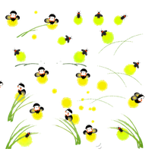
(A) are dangerous sometimes
(B) are important in many cultures
(C) are active at night
(D) are different from butterflies

(A) same | (B) own
(C) new | (D) real
If you have a sister, then you should go and give her a hug. You should thank her for making you happy. Does that sound strange to you? Actually, a recent study found that teenagers with sisters are less likely to feel sad. Brothers and sisters have different ways of comunicating. During difficult times, sisters usually talk more about personal things, such as their feelings. They also communicate more often. Your sister can help cheer you up. She might not even mean to! Not everybody enjoys talking about personal things.

In fact, many sisters in the study didn’t especially enjoy those talks. The key to a closer relationship is how often people spend time together. People help one another feel happier by having more conversations. You mihgt talk about baseball, your jobs, or even not talk at all. Simply keeping somebody company can help lift the dark clouds from their bad day. People need to communicate with others to feel happy. So next time your friend is feeling blue, just do what your sister would do!

- According to the passage, how can you keep a closer relationship with others?
(A) You have to get in touch with them more often.
(B) You must have a brother or a sister.
(C) You should go and give them a hug.
(D) You can talk about personal things with them.
- What does She might not even mean to mean?
(A) She might be afraid of talking to you. | (B) You must be mean to you.
(C) She might not do it on purpose. | (D) She might not cheer you up.
- What is the best title for the passage?
(A) Why You Should Have a Sister | (B) How Sisters Save Us From Being Sad
(C) Why Sisters Are Better Than Brothers | (D) How People Spend Time Together
If you have an old T-shirt or a puzzle that you don’t want anymore, you don’t have to throw it out. Why not bring it to a flea market? Flea markets are similar to ordinary markets, except for on thing: all of the products in flea markets are secondhand. People bring their old products to flea markets, and sell them at a discount. If they don’t sell their things, then they might trade with someone else. For example, one person might trade his old radio for a pair of roller skates. Flea markets are great because they help us save money. They also stop us from wasting the things that we own. Moreover, there is another advantage to flea markets: they’re a lot of fun.

- What is the passage mainly about?
(A) How to sell old things at a flea market.
(B) Why there are secondhand things at flea markets.
(C) Whether things at flea markets are cheaper.
(D) Why flea markets are so good.
- Which of the following is NOT true about the flea market?
(A) There is no difference between flea markets and other markets.
(B) There are a lot of used things at flea markets.
(C) You can buy things at flea markets for a lower price.
(D) You will have a good time if you go to a flea market.
- What does advantage most likely mean in the passage?
(A) Difference. | 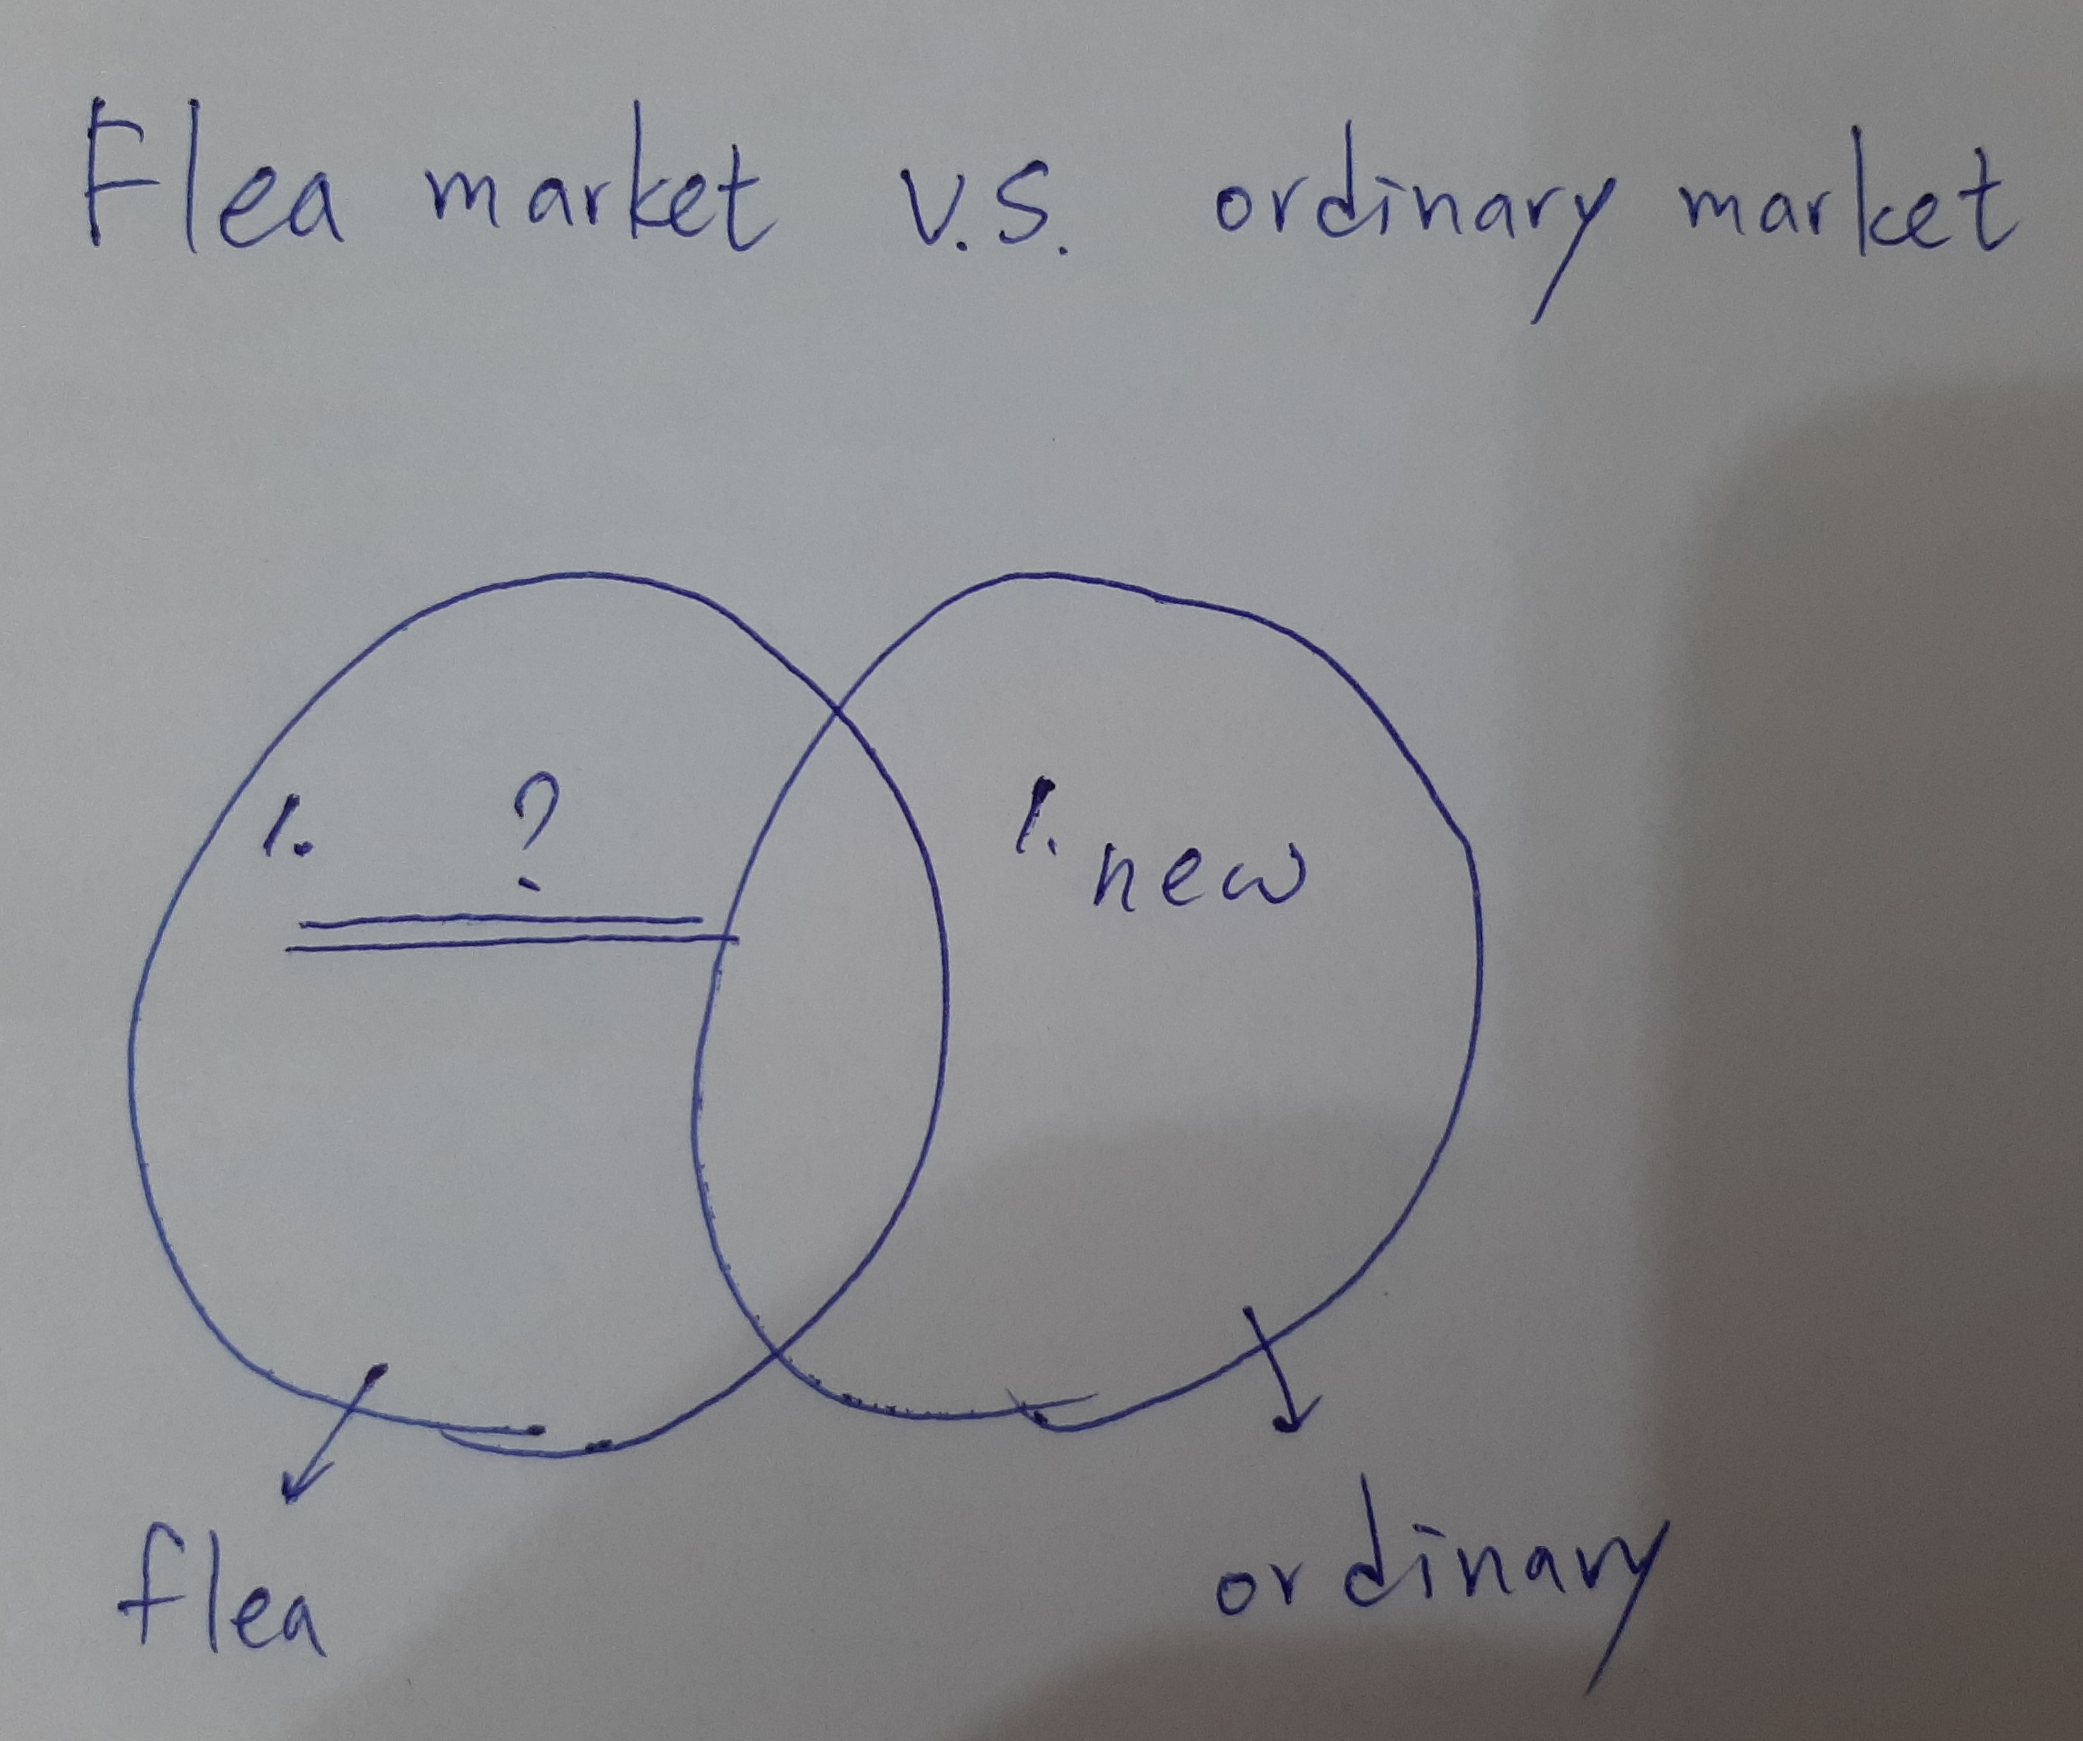(B) Choice.
(C) Value. | (D) Success.
- The Venn diagram of this article.
Which one may be in the blank?
(A) new | (B) expensive
(C) secondhand | (D) broken

- 整句式翻譯：8%
- Jack與來自美國的訪客們分享了許多這古寺廟的照片。(3%)
- 你的胃怎麼了嗎？你需要一些藥嗎？(2%)
- 因為我鄰居一直製造噪音，所以我昨晚沒睡好。（......so......）(3%)

天主教道明中學第109學年度第一學期第一次段考二年級英文科試卷
班級：_____ 座號：_____ 姓名：_____________

(請用藍筆或黑筆作答)

手寫 (20%) | 選擇 (80%) | 總分 (100%)

- 單字填空：12%
1 |  | 2 |  | 3
4 |  | 5 |  | 6

- 整句式翻譯：8%
- Jack與來自美國的訪客們分享了許多這古寺廟的照片。(3%)
_____________________________________________________________________________
- 你的胃怎麼了嗎？你需要一些藥嗎？(2%)
_____________________________________________________________________________
- 因為我鄰居一直製造噪音，所以我昨晚沒睡好。（......so......）(3%)
____________________________________________________________________________
天主教道明中學第109學年度第一學期第一次段考二年級英文科試卷
班級：_____ 座號：_____ 姓名：_____________

- 單字填空：12%
1 | ballooned | 2 | experience | 3 | through
4 | brought | 5 | treats | 6 | afraid

- 選擇題：80%
1 | 2 | 3 | 4 | 5 | 6 | 7 | 8 | 9 | 10 | 11 | 12 | 13 | 14 | 15 | 16 | 17 | 18 | 19 | 20
C | D | A | D | C | A | D | D | C | C | A | B | C | A | D | C | B | B | A | B
21 | 22 | 23 | 24 | 25 | 26 | 27 | 28 | 29 | 30 | 31 | 32 | 33 | 34 | 35 | 36 | 37 | 38 | 39 | 40
B | B | C | A | C | A | B | D | C | B | C | A | B | D | D | C | A | A | D | B
41 | 42 | 43 | 44 | 45 | 46 | 47 | 48 | 49 | 50 | (1~30:2% ; 31~50:1% ) 80%
A | B | B | A | C | B | D | A | C | C

- 整句式翻譯：8%
- Jack與來自美國的訪客們分享了許多這古寺廟的照片。(3%)
Jack shared many pictures of the old temple with visitors from the USA.
- 你的胃怎麼了嗎？你需要一些藥嗎？(2%)
What happened to your stomach? Do you need some medicine?
- 因為我鄰居一直製造噪音，所以我昨晚沒睡好。（......so......）(3%)
My neighbor kept making noise ,so I didn’t sleep well last night.

