天主教道明中學第110學年度第一學期第一次段考三年級英文科試卷
命題老師：國三教師群

- 單字填空：6% (請於答案紙上，用黑或藍筆寫出完整的單字。)
- The Statue of Liberty is a s_______l of friendship between France and the USA.
- Timmy used to be a s_______r when he was young. He fought for his country.
- Do you want some s_______es to go with your eggs? We all love the traditional English breakfast.
- Tim’s plan helped us get through difficult times. Though I don’t like him, I have no c_______e but to agree that he has done a wonderful job this time.
- Though our plan was not s_______l, I still learned a lot from this experience.
- I gave Timmy a t_______p on the shoulder to let him notice me.
- 選擇題：(1~10 :1% ; 11~50:2% )：共90%
- Cindy _______ math in 2003 and bought a fancy car the next year.
(A) is teaching | (B) teaches | (C) has taught | (D) taught
- Mark moved to Japan last year and _______there since then. He really loves the country.
(A) lived | (B) has lived | (C) is living | (D) was living
- A: Has John _______ to the UK? B: Yes, and he will stay there for 3 weeks.
A: Wow! It’s so nice. B: I envy him, too.
(A) ever been | (B) gone | (C) go | (D) already went
- For the past thirty years, my mother _______as a nurse in a school. But she will leave the job next semester.
(A) has worked | (B) worked | (C) is working | (D) works
- I can’t believe that you really _______ over five thousand for the red wine. The _______ of our food for this month has become too high.
(A) spent ; cost | (B) spent ; spend
(C) paid ; cost | (D) spend ; pay
- Fanny has decided to move to Tainan next month. When she works in the new company, she _______ with her grandmother for 2 weeks.
(A) lives | (B) has lived | (C) lived | (D) will live
- Sara _______ hamburgers for dinner every day last month.
(A) has had | (B) has | (C) had | (D) was having
- Tina and her husband aren’t home. They _______ the movies already.
(A) has gone to | (B) have been to | (C) have been in | (D) have gone to
- No _______. Everything will be fine. Now, just go outside and have fun with us.
(A) worrying | (B) worry | (C) worried | (D) worries
- I forgot to bring my wallet with me, so my sister _______me $10 to buy a drink.
(A) borrowed | (B) paid | (C) lent | (D) spent
- There are four stories in this book. The one about the brave firefighter is the most ______ to me.
(A) interest | (B) interested | (C) interestingly | (D) interesting
- Jenny said she _______ the floor after dinner, but she _______ that. Her mom is mad at her now.
(A) mopped ; stopped doing | (B) would mop ; forgot to do
(C) would mop ; forgot doing | (D) was mopped ; remembered doing
- Aren’t you _______ with watching the same TV soap dramas every day?
(A) boring | (B) will bore | (C) bored | (D) be bored
- My mother told me yesterday evening that we _______ to the Food Festival this weekend. My brother and I ________ very excited.
(A) are going ; felt | (B) would go ; am | (C) went ; are | (D) will go ; are
- Study hard_______ you want to pass the important exam.
(A) if | (B) that | (C) so | (D) though
- Cooking lessons _______ Peter a lot, so he took more lessons this summer.
(A) are interested | (B) interested | (C) are interesting | (D) interests
- Among all the haunted houses, this one is the most _______. Someone saw ghosts appear there.
(A) scary | (B) scare | (C) scared | (D) scarying
- A: Have you ever been to a baseball game? B: No, never. _______
(A) Do you? | (B) Did you? | (C) Are you? | (D) Have you?
- A: Has your son _______ the dishes? B: No, he _______.
(A) do ; has | (B) did ; haven’t | (C) done ; hasn’t | (D) done ; have
- Lydia _______ a new job two days ago. Let’s cheer for her.
(A) found | (B) has found | (C) finds | (D) is finding
- _______he hurt his knee, Sam’s never played basketball again.
(A) Until | (B) Since | (C) Ever | (D) Before
- My old hairdryer is _______. I’m going to buy a new _______ later.
(A) break ; it | (B) broke ; another | (C) broken ; one | (D) breaking ; that
- Visiting these elder people _______ my habit since my parents _______ me here once.
(A) become ; take | (B) has become ; brought | (C) became ; has take | (D) becomes ; will bring
- This morning, a lot of people were surprised _______ know the news of the famous star’s death.
(A) at | (B) that | (C) to | (D) about
- Hiking is one of my _______. I enjoy hiking in my free time.
(A) interests | (B) interest | (C) interesting | (D) interested
- Kevin looked _______ when he opened the gift.
(A) exciting | (B) excite | (C) excited | (D) excitingly
- Ken said _______ was more fun to go shopping with friends than to go jogging.
(A) it | (B) that | (C) there | (D) one
- Which one is right?
(A) The beautiful lady is very younger than her classmate.
(B) If it will rain tomorrow, we will not go on a picnic.
(C) Julia has waited for the train when she got a phone call from her father.
(D) The little boy would like to invite all of you to his birthday party.
- Which one is right?
(A) Lisa has been crazy about music since she was a little girl.
(B) My grandfather has died for ten years.
(C) Mike has come to Taiwan for twenty years.
(D) He has kept the cat since three days ago.
- Which one is Wrong?
(A) Do you usually pay with your credit card when you go shopping?
(B) Helen paid a day in the department store looking for a ring for her husband.
(C) Studying in a foreign country will cost you a lot of money.
(D) It will take you at least twenty minutes to get there.

Many people are crazy about Apple’s products, iPad and iPhone. They have been popular since they __31__ out, but have you heard of Apple’s latest product, iRing? It’s not a common ring. It can make our life more convenient.
The news about iRing __32__ Apple fans. Although they can’t have one now, they are able to buy it by the end of the year. It’s a cool product just like a small controller. If we wear iRing, we can control our music player more easily. iRing only comes in two colors, black and white. We don’t have many color choices.
Do you want to buy one? Before you make the decision, you need to save enough money first. It will definitely __33__ you a lot of money.



(31) | (A) are coming | (B) came | (C) come | (D) will come
(32) | (A) excites | (B) is excited to | (C) is exciting | (D) is excited about
(33) | (A) pay | (B) spend | (C) cost | (D) take

The word “sandwich” first appeared in the 18th century. John Montagu, the fourth Earl of Sandwich in England, often gambled at London’s Beef Steak Club. Sometimes he stayed at the gaming table for twenty-four hours. He didn’t want to stop gambling even when he was hungry, so the cooks at the club put some beef between two pieces of bread for him. This way, the earl could eat without leaving his seat. This new kind of food became very fashionable, and the people in the club named it a “sandwich” after the earl. Then in 1837, an American writer wrote a recipe for ham sandwiches in her cookbook. Sandwiches became very popular after that.

34. What is the correct order of the ideas from the reading?
①An American writer wrote a recipe for ham sandwiches.
②The fourth Earl of Sandwich spent hours at the gaming table and didn’t want to leaver for meals.
③The cooks at the club made a new kind of food for the earl to be able to eat and gamble at the same time.
(34) | (A) ③→②→① | (B) ②→③→① | (C) ①→②→③ | (D) ②→①→③
The Difficult Life of Becoming a K-Pop Star
Many people all over the world are interested in becoming a popular star. At the top of the list are teenagers from South Korea. However, before those young boys and girls can even dream of being successful in the K-pop world, they have to be trainees first. That, in fact, is not as easy as many people think.
First, these South Korean teenagers spend years working hard on their training. They are away from their families and feel alone from time to time. Besides learning to sing, dance, and act, they still need to find time to do their schoolwork. What’s more, most of them don’t have any freedom because they have to follow orders from their companies. For example, they can’t eat too much because they have to watch their weight.
Life as a trainee can be hard and tiring. Many trainees may give up their dreams because they can’t get through the difficulty. If you are interested in being a K-pop star, make sure you really want it. If that’s not the case, you may just find your dream fading away as grow older.

35. What is the correct order of the ideas from the reading?
① South Korean teenagers want to be pop stars.
② Be sure about your dream.
③ K-pop trainees and their problems.

(35) | (A) ③→②→① | (B) ②→③→① | (C) ①→③→② | (D) ②→①→③


Pearl milk tea and other tea-based drinks __36__ popular in Taiwan for several years. You can see drink stands everywhere. The drinks taste delicious, and so many people enjoy __37__ one cup a day. __38__ healthy, a lot of people ask for half-sugar when they order these sweet drinks. However, they don’t know that they become fat by drinking those drinks.
A foundation found the surprising truth. They found __39__ more than half of the drink stands did not really reduce sugar by half. “We suggest parents take children’s health seriously. If children drink too many sweet drinks, they will become fat. If they really want to have some cold drinks, they can have fresh juice instead.” __40__ by the spokesman of the foundation. (spokesman: 發言人)

(36) | (A) were | (B) are going to | (C) will be | (D) have been
(37) | (A) to drink | (B) drink | (C) drank | (D) drinking
(38) | (A) To stay | (B) Stay | (C) Staying | (D) Stayed
(39) | (A) after | (B) that | (C) where | (D) when
(40) | (A) saying | (B) says | (C) said | (D) say

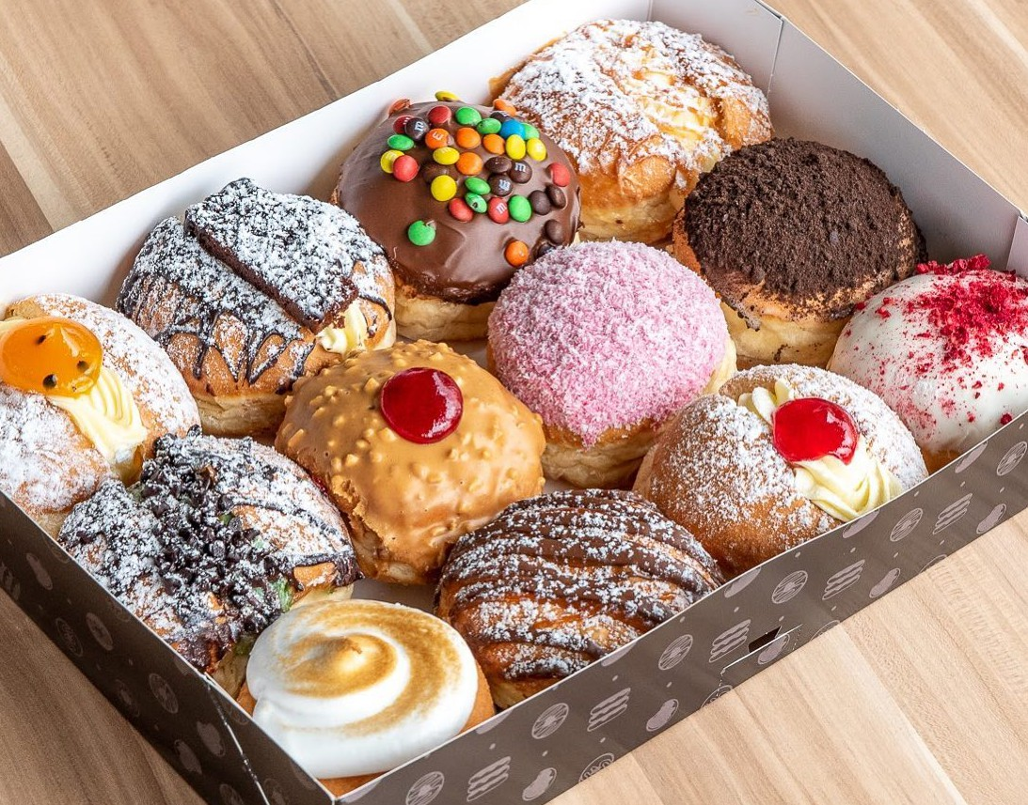
Many Americans are crazy about having yummy donuts for breakfast. __41__ for centuries. They are popular not only for their low price, but also because of their great taste. Maybe you have wondered about their __42__.
Why do they look like rings? Who first put holes in them?
In 1847, Hanson Gregory was working on a ship when he made the first ring-shaped donut. Every time Gregory went to work, his mother__43__ a box of round dough balls for him. However, it was hard to cook the centers all the way through, so they often came out raw. One time, Gregory didn’t want to eat that part anymore, so __44__. There are many stories about donuts, but this one is the most popular.

(41) | (A) People have eaten breakfast
 | (B) Donuts have been famous
 | (C) Americans love making donuts
 | (D) American breakfast has been famous
(42) | (A) sweet taste | (B) special recipe
 | (C) different colors | (D) interesting shape
(43) | (A) prepares | (B) is preparing
 | (C) has prepared | (D) would prepare
(44) | (A) he cut it out with the top of a can
 | (B) he cut the dough into smaller balls
 | (C) he never brought any dough balls onto the ship
 | (D) it was hard for him to make the dough the right way
We all need food to live, but we don’t always have time to make it ourselves. Luckily, there are food delivery services. They bring food right to our doors. Now, more and more restaurants work with food delivery companies. __45__ Their apps are easy to use, and people can order and pay easily.
Food delivery services are convenient for customers. They can order almost anything, and they can also try new restaurants. On the other hand, __46__. They can get new customers. They can also take orders when the weather is bad. __47__ There may be traffic jams, and customers have to wait longer for their food. There could also be problems with the apps, and the restarurants will lose money on wasted meals. Even so, many people still think food delivery services are great, and they can’t live without them.

(45) | (A) They deliver their food to companies in a faster way.
 | (B) The big ones in Taiwan are Foodpanda and Uber Eats.
 | (C) People are tired of preparing their own meals every day.
 | (D) The food delivery companies know everything about you.
(46) | (A) tasting new food is always interesting
 | (B) they can even make more friends by sharing their food
 | (C) the food delivery apps can also save them a lot of time
 | (D) for restaurants, food delivery services help grow their business
(47) | (A) So, the delivery apps are easy to use.
 | (B) Besides, people want to stay at home more.
 | (C) However, food delivery services aren’t all good.
 | (D) As a result of that, people have changed their eating habits.
Plastic makes our lives easier, but it is also making the planet, animals, and people sick. It’s everywhere. It’s in the ground, air, and water. Every year, over seven billion kilograms of plastic goes into our oceans alone. Because of this, many people want to stop using plastic.
Taiwan is one of a few countries trying to solve the problem. In 2019, the country started by banning some restaurants from giving plastic straws to customers. Now, only people that order food to take home or go to drink shops can get straws. And soon, those places will also have to stop.
Straws are a big source of pollution, and Taiwanese use over three billion plastic straws a year. That is almost half of the eight billion straws polluting beaches today. Lowering the number of straws Taiwanese people use will make a big difference.

Taiwan is not the only place doing this, either. Great Britain, Scotland, and a few US and Canadian cities are also trying to stop people from using plastic straws. Because straws are not necessary, many see it as the perfect place to start.

48. Below are the writer’s points in the report.
① Taiwan wants to lower plastic pollution.
② Plastic pollution does a lot of damage.
③ Several places want to stop the use of plastic straws.
In what order does the writer talk about his or her points?
(48) | (A) ①→②→③ | (B) ②→①→③ | (C) ③→①→② | (D) ②→③→①

(49) | What does the report say about plastic in the ocean?  (A) Most plastic straws are found in the ocean.
 | (B) Seven billion kilograms of plastic comes from the ocean.
 | (C) Taiwan throws billions of kilograms of plastic into the ocean.
 | (D) There are over seven billion kilograms of plastic in the ocean.
(50) | Which idea might the writer agree with?  (A) People don’t need to use straws.
 | (B) No one should swim in the ocean.
 | (C) Plastic straws aren’t a big problem.
 | (D) Restaurants should stop selling drinks.

- 整句式翻譯：4%

- 可以請你關上窗戶嗎？我要凍僵了！(2%)
- 有了這個有用的食物外送應用程式，我們不必冒雨出門。 (2%)

